
Lessons Learned

Using a Utility Knife

Sequence of Events:

One of our technicians was "auguring" a hole in a piece of plastic for some ductwork. As he was using a lot of downward force, the blade slipped off of the piece of plastic and lacerated his pinky finger on his right hand. 6 stitches to close it up. No bone or tendon injury.

Root Cause(s):

1) Improper methods (Administrative Controls)
2) He has done this many times-false sense of security. No JHA for this.

Impact:

A painful injury that had the potential of being more severe.

Corrective Actions/Recommendations:

First, our technician was using his gloves-Kudos for that. In speaking with our technician he feels he had the proper cut resistant glove in use. They are our company issue cut level 2 glove. He said that with the amount of force he was using, he could have cut through his boot.
He also told his supervisor that he feels that if he did not have his gloves on, he would have lost his finger.
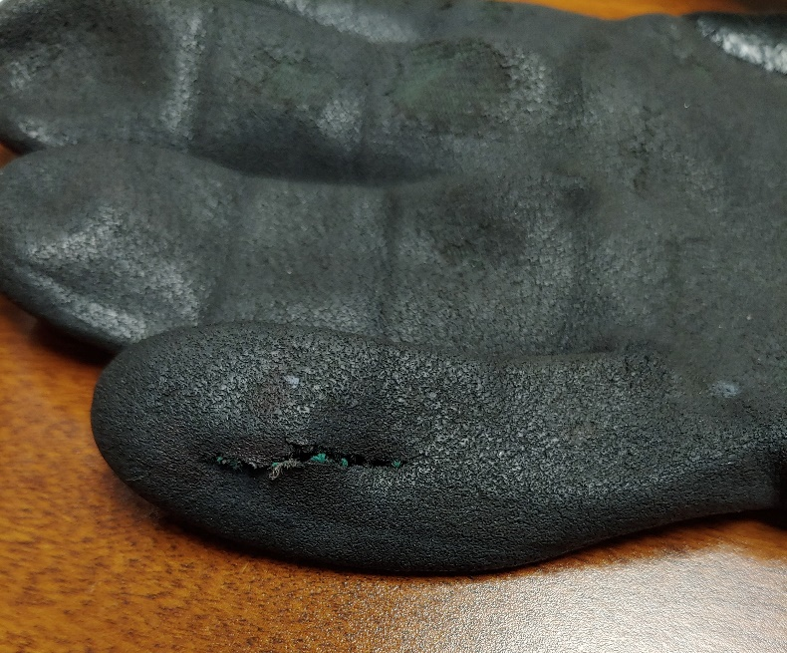

I agree with that he was using the right glove for the task. This is the first laceration in which someone has punctured a glove. The cut level 2 gloves would still be appropriate for this task but, here is what to do different. Our technician did mention that next time he would strap the piece down so he wouldn't have to hold it. I 100% agree with this. Remember, PPE is the last line of defense. Administrative Controls (AKA- how you perform the task) comes before PPE in the Hierarchy of Controls for Hazards.

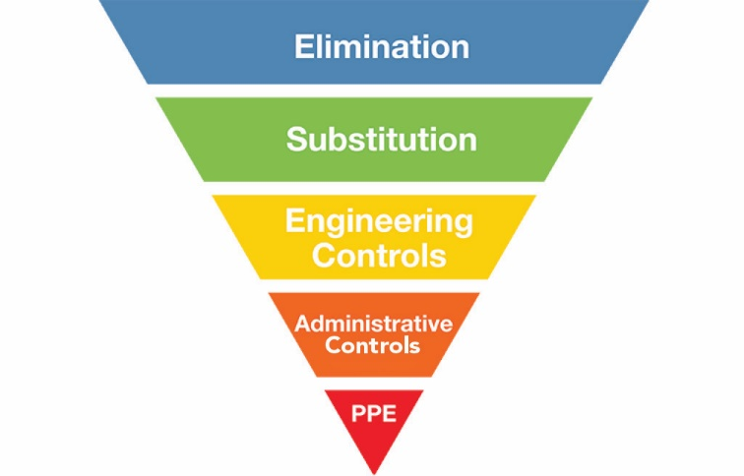

So planning how you are to perform the task can be life saving, or in this case, finger saving. Our technician is one of the best when it comes to filling out his JHA for the task. He had not done one for this project, or at least not on record. It is so easy to become complacent, after all, we do this work every day. Remember, we do have an enemy called injuries, but we do have the tools and training to beat it. Let's use them.

Respectfully,

Brian Desrosiers, SMS, CHST
Safety Director
Piedmont Service Group

