
Lessons Learned-Refrigerant Pump Down

Incident Date-2/14/18 at 8:01 am
Equipment- Trane Odyssey, 20t, Model #TTA240H400AA, MFG- 1/2016
Compressor- Trane Model # CSHD120K0B0M, Part # COM09857

Sequence of Events:

Our technician was going to install a new solenoid valve on the liquid line side of a unit. So as to be friendly to the environment, cut down on wasted refrigerant and speed things up he was going to "park" or pump down the R-410a in to the condenser so he could perform this task.
1) The technician attached his gauges to the suction and liquid service valves. See diagram below.
2) He then closed the liquid service valve.
3) He started the compressor by pushing in the contactor with a pen.
4) As the refrigerant was being moved into the condenser, the compressor continued to pump (suck) until failure. The discharge line in front of the compressor exploded.
Impact:

There was an explosion that captured the attention of all around. Our technician was not injured. He was standing to the right side of the compressor as he initiated the contactor. The unit needed replacing.

A crane was required to switch out the old unit with another. The cost for the total fail, $5,000 +.

The possible impact from this could have been a fatality if our technician was standing a couple of feet to the left. The force of the explosion did knock him on his tail.

Root Cause(s):

1) Improper means and methods. You cannot perform a pump down procedure on a unit that has micro channel condenser coils such as this unit has. (see excerpt below)
2) Pumping down with a scroll type compressor is not recommended by the manufacturer.
3) Unfamiliarity with this style of condenser coils.
4) Using the contactor to start the compressor overrode the High Pressure Cut Out located in the discharge line. This model Trane Scroll Compressor does not have an internal relief device.
(Trane Scroll Compressor Application Data Page 14-High Pressure control)
5) His gauges should have been on the suction line and discharge line. This would have shown the pressure increase and alerted him something was wrong. It would have been at least 400 PSI +.
6) No Job Hazard Analysis was done.
Other misses:

In the investigation of this it was found that no thought was given to shock protection or arch flash protection being the technician was within the Restricted Shock Boundary and Arc Flash Boundary. The technician was about 6" from energized 480v 60a.

Lessons Learned

It is the best case scenario when we can learn a lesson without a cost. Unfortunately this one did cost us financially. The good news is we did dodge a bullet, literally, and our technician is still around to tell the story.
So going forward we have this to remember:

1) You cannot use a pump down procedure on micro channel coils.

Here's the proof: Trane sent out a General Service Bulletin-Micro Coil Servicing Guidelines, Page 5 Par 2

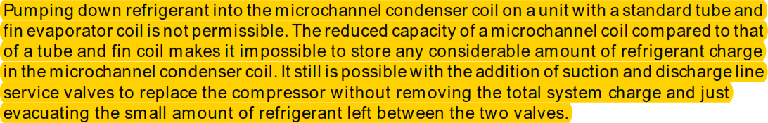

This means that even though you have always done this, doesn't mean you should continue. Equipment changes. We need to stay current on what is acceptable. We need to share this info. The bulletin above was distributed May 2011.
Jose missed this step with his left foot.
Jose had his right hand here.

2) Proper placement of gauges. See illustration below. By not having a gauge on the discharge line, it did not alert him to the increased PSI to the point of a failure.

3) Do not bypass the safety mechanisms by engaging the contactor. This could continue to energize the compressor to failure.

4) A Job Hazard Analysis needs to be completed. This would help to identify the hazards, such as shock potential, arc flash potential and many other hazards that this scenario could include.

For this task, Per NFPA 70e the restricted approach boundary for shock is 1"-0". This means for shock you would wear you rubber gloves with your leather gloves over them.

For the arc flash boundary, per Table D.4.7 calculations for a 60a 480v breaker with an interrupter current of 18 KVA, your arc flash boundary would be at 14"@ 1.2 cal/cm². This means you could perform this task with just a cotton or non flammable shirt and be safe and compliant. (Additional arc flash protection is required when the incident energy is at 18"@ 1.2 cal/cm²). Of course, you would still use your safety glasses.

Respectfully,

Brian Desrosiers SMS, CHST
Safety Director

"We Make Buildings More Efficient"
Gauge attachment diagram

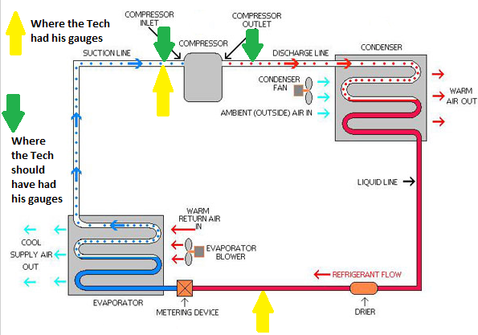

Here is a picture of the unit right after it exploded

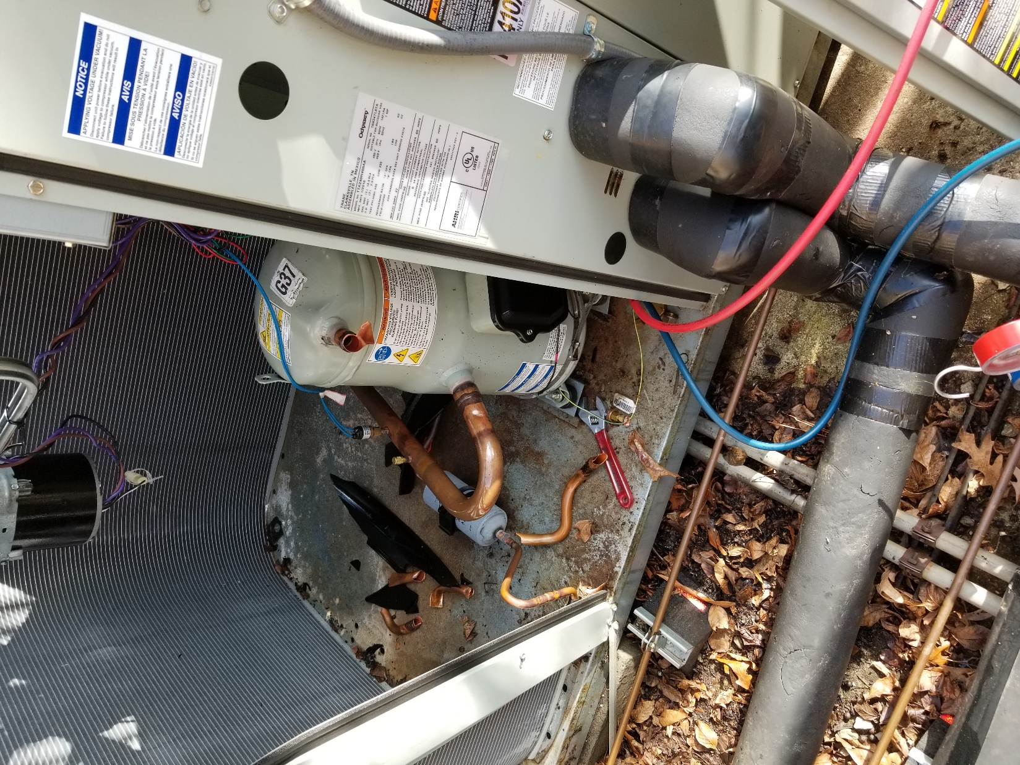

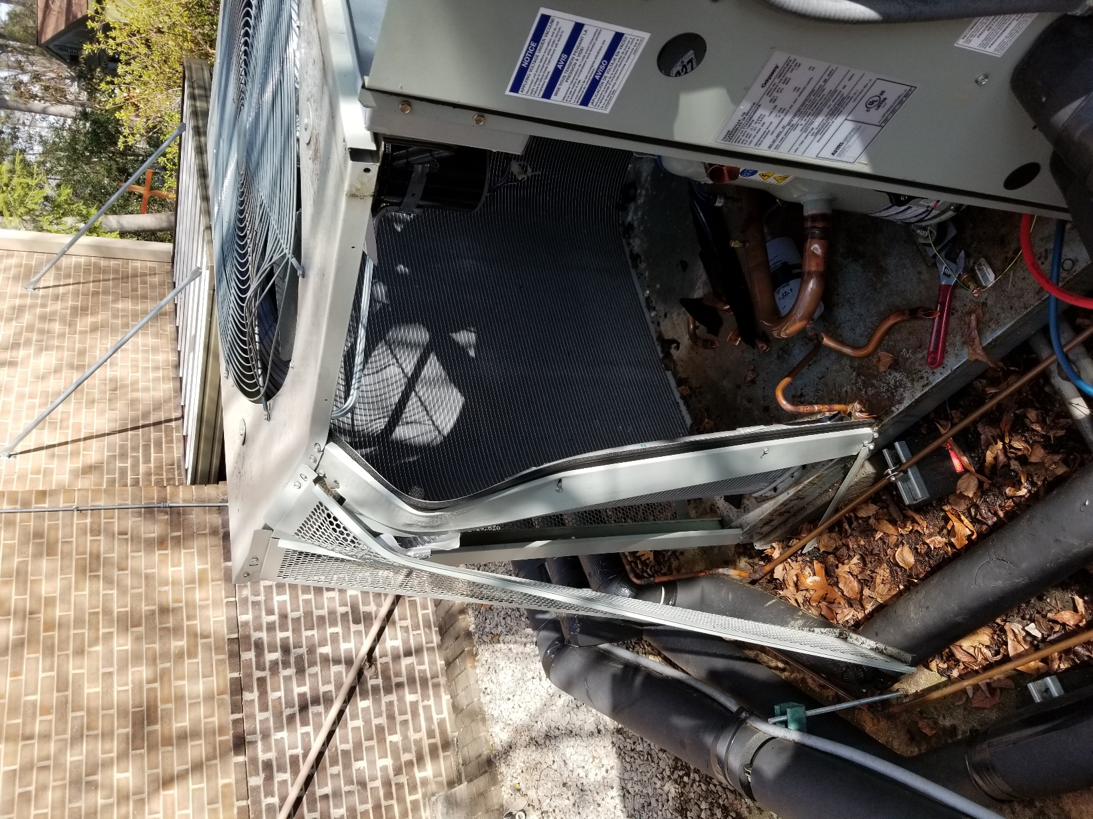

This is where our Technician was standing when it exploded

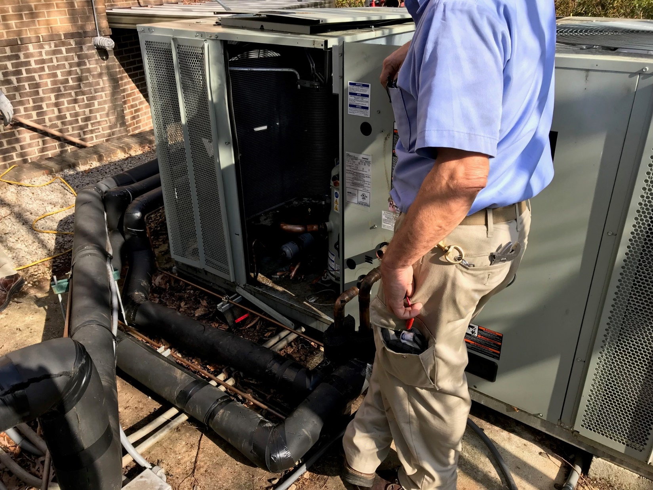

MicroChannel Design
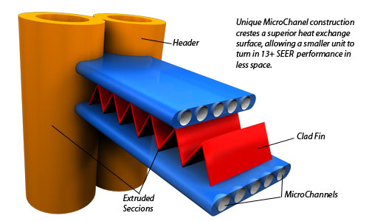

This is where our Technician had to engage the contactors, about 6" from energized 480v conductors
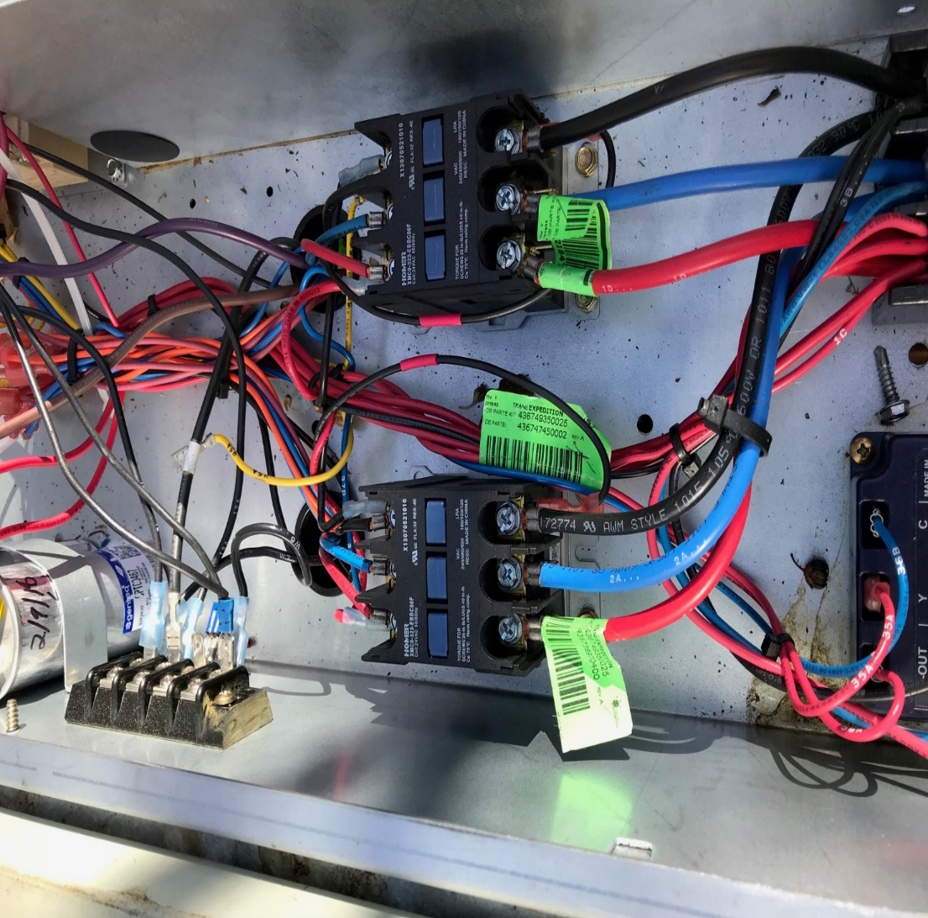
Trane Scroll Compressor
