Lessons Learned

Sprained Ankle

Sequence of Events:

Two technicians were performing maintenance on some roof top units. One technician had previously set up his 24' extension ladder and secured it. As he was stepping off the ladder onto the roof, he slipped on some leaves and sprained his left ankle. The other technician did not see this since he was washing coils and surrounded by a fence. Later on he did see him limping later on and asked what happened.
Here is a picture of the ladder location. The parapet wall is 22" high. In speaking with both technicians, they both said they would pull up materials here. The injured technician went to the urgent care. They diagnosed a left ankle sprain. In a boot for 4 weeks. Follow up visit in 2 weeks. Restrictions. OSHA recordable.

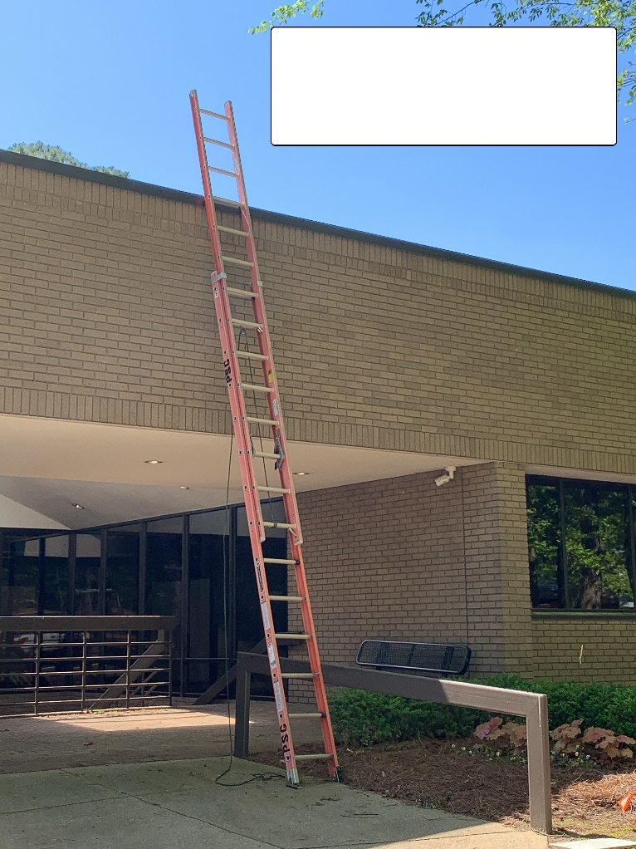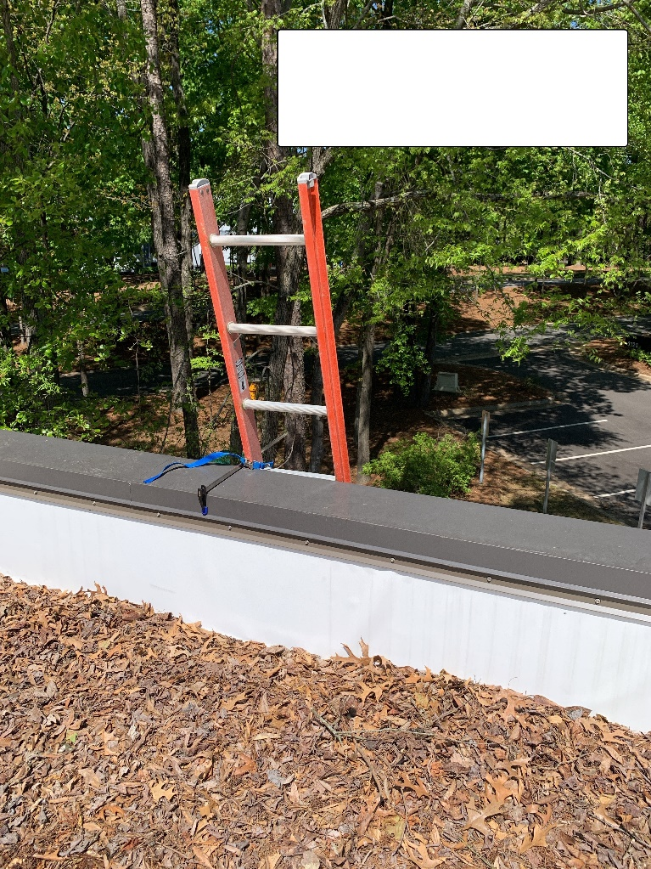

By choosing to use an extension ladder, you have to walk through leaves, water, mildew and next to an unprotected skylight. The other option would be to use the fixed ladder.

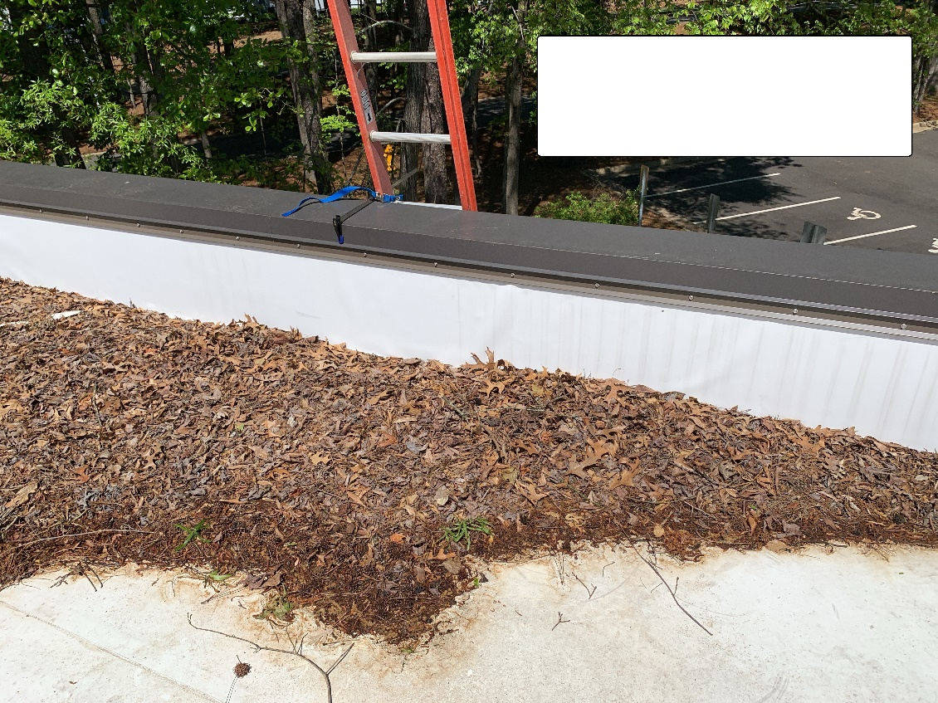

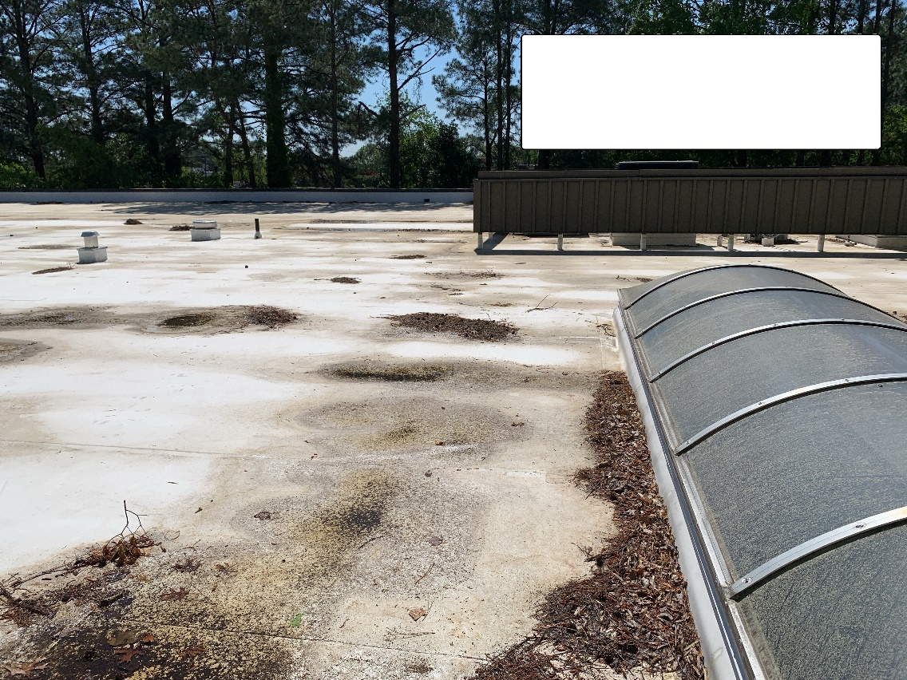

Root Cause(s):

Initially you would say, that slipping on leaves just happens. But when we dig a little deeper, some interesting things come to light. There is another way to access this roof. There is a fixed ladder. When you use this fixed ladder you are able to walk on a dry roof to the units. You also can avoid the unprotected skylight. You have to be 15' away to be compliant. I asked both technicians why they didn't use the fixed ladder and they said it takes too long to get the key.

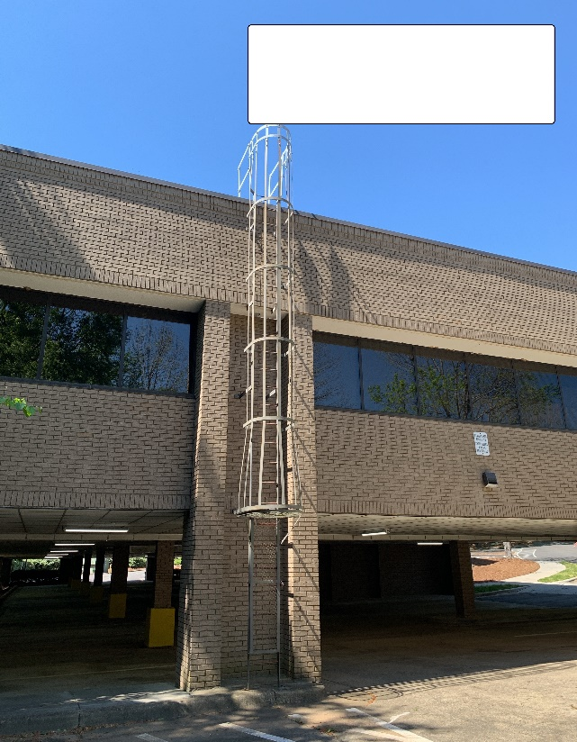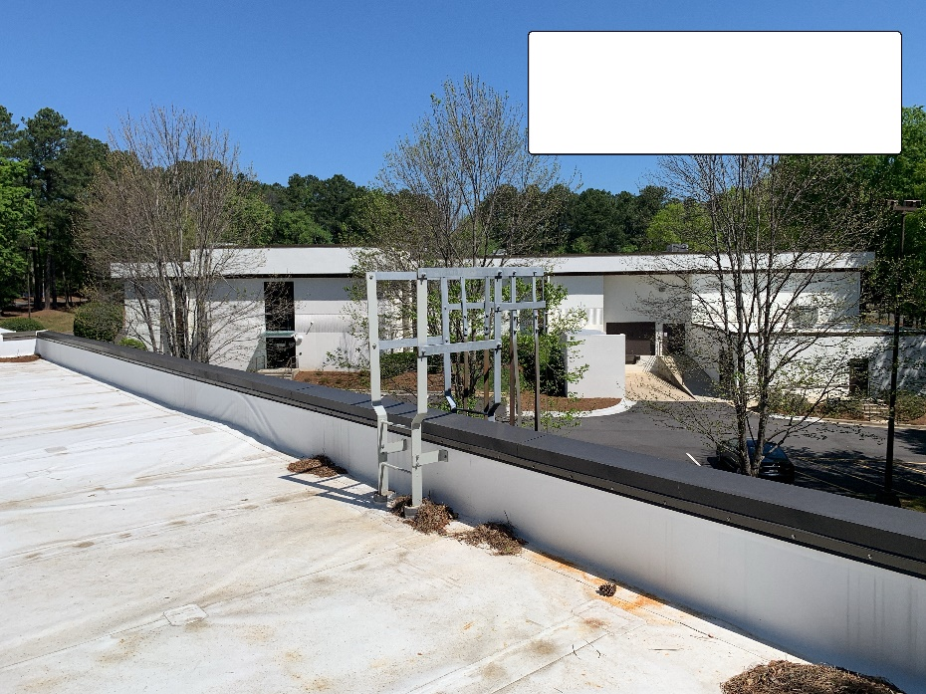

If you use the fixed ladder, the next picture shows a route with no water, leaves or mildew. Plus, a place to tie off and pull up materials. See the example in the lower right picture.

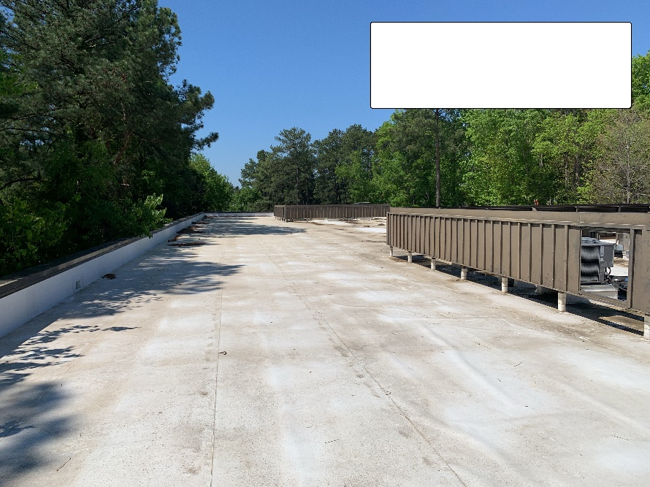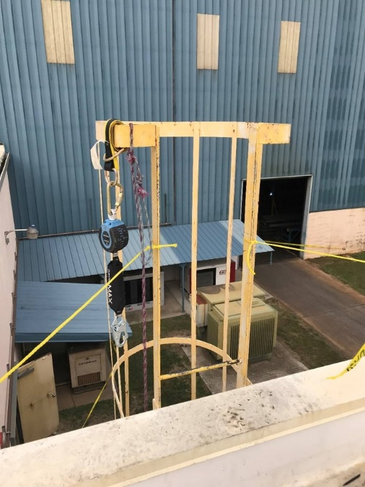

Something else that comes into play here is pre task planning, using your JHA. The JHA asks some specific questions that might cause you to realize that you need to use the fixed ladder (see below) and use fall protection to pull up materials. There was no JHA completed for this task/day by either of the technicians.

I will have to say that the root cause of this accident is not the leaves, but not thinking ahead and using the JHA tool. Something else that needs to be considered is how to get your tools and materials up. Unless you have a wall at least 39" high, you are at risk and not compliant. Fall protection is required. You can tie off to a fixed metal ladder with your Harness and SRD.

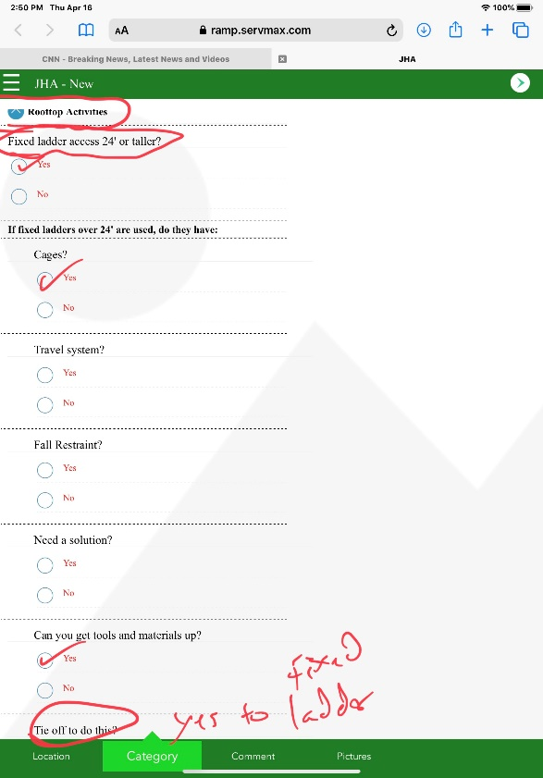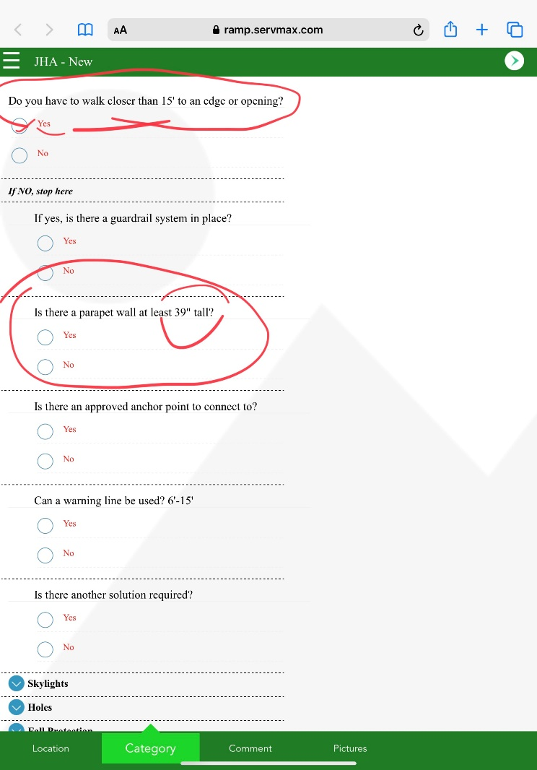

Impact:

Our technician has a painful injury with a boot and physical therapy. He will be on light duty for 6 weeks or so. That is if everything heals up as it should. This means we are down a tech for 6 weeks. Fortunately, OSHA did not see this. We could have received a citation for not having fall protection as the guys stood at the 22" parapet wall and pulled up tools.

Corrective Actions/Recommendations:

JHA's need to be completed. The process works when used. You need to take a minute or two to evaluate the best way to access and perform your work.
If the key is an issue, let's have a meeting with the owner and request something to be done, such as a combo lock or a lockbox.
Fall hazards and Access are our two biggest risks. We don't have an option, we are required to use fall protection when 4' or more above the ground. This is every roof.
More importantly, we should want to do this to keep our workers safe. But, also remember this can have a big financial impact in the way of an OSHA citation or a lawsuit. Plus OSHA citations affect current and future work.

Respectfully,

Brian Desrosiers, SMS, CHST
Safety Director
Piedmont Service Group

