
Lessons Learned-Sprinkler Incident

Sequence of Events:

One of our workers was pushing flex duct through some ductwork strapping he had hung from the ceiling. He had looped the strapping as shown in the picture below. He had his vice grips on the loop to help with this process. As he was wiggling the flex duct through the loop, his vice grip hit a charged sprinkler head. I think the next is obvious, water everywhere. The superintendent for the GC jumped in to help locate and shut the zone down. All personnel on the floor jumped in to help stop and vacuum up all the water. Many gallons had escaped. This was on a third floor of an occupied Health Care building. The floor below did sustain minimal damage. The quick response of all did contribute to mitigating the damage. Five rooms below did need to be dried and cleaned. The rooms included a conference room and exams rooms. We were very fortunate to not have flooded the server room which was a couple of feet away from a room that sustained damage.
The bottom 2 floors of the building were evacuated after the sprinkler was activated.

Root Cause(s):

Unsafe actions and an unsafe condition that was created by the placement of the vice grips.

Impact:

This was a costly lessons learned. This also had the potential to do some major damage to an occupied building.

Corrective Actions/Recommendations:

We take away 2 very valuable lessons from this. I hope all benefit from this.

1) Our workers will slip and make mistakes. How can we account for this? For this scenario, when working around charged sprinkler heads, protect the head with a cage. They are cheap insurance. 69 cents a piece. I recommend any of our crews that this applies to, purchase these and pass them out to your crew.
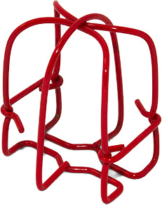
https://www.supplyhouse.com/FPPI-02-600-00-1-Piece-Sprinkler-Head-Guard-Red?gclid=EAIaIQobChMIuLLIlt3h4wIVkZOzCh3B_gvQEAQYBCABEgI0f_D_BwE

2) When working around any live system, locate the shut off and make sure you know how to operate it. In this case, you first have to shut off the water supply and then drain the correct zone. Minutes lost locating the shut off quickly adds $$ to the cost of repairs needed.

Respectfully,

Brian Desrosiers, SMS, CHST
Safety Director
Piedmont Service Group

