
Lessons Learned-Fractured Finger

Sequence of Events:

One of our Sales Team was performing an equipment survey on a RTU. The unit was shut down, but the belt and pulley of the fan motor was still moving. He attempted to slow the belt down with his left hand. The belt grabbed his glove and pulled his index finger into the pulley. The painful results were a fractured finger. Fortunately at this time no surgery is needed.

Root Cause(s):

1) The hazard was not eliminated with LOTO (Lock Out Tag Out) (Elimination)
2) Improper methods (Administrative Controls).

Impact:

A painful injury that had the potential of being more severe. Some have lost their finger attempting to do this.

Corrective Actions/Recommendations:

Use LOTO.
LOTO is not just a cool acronym but a requirement and a life saver. This applies to all types of energy, kinetic, hydraulic, electric, steam, chemical, etc. Remember the 6 steps.

1) Prepare, determine how to control the energy
2) Shut it down
3) Isolate all energy sources
4) Apply LOTO devices
5) Release stored energy
6) Verify zero energy.

Also, especially when testing and troubleshooting, always avoid moving parts or parts that can move. As you are doing your Job Hazard Analysis, think of what can go wrong so you can avoid it and control it.

Please remember that energy is not prejudice. If you try to stop it, it doesn't often end well. So whether you are a Technician, Project Manager or anyone in our company, at home or on the job, let's eliminate the hazard before it harms us.

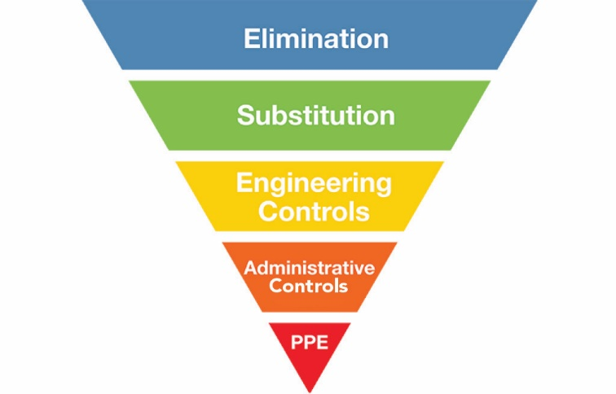

Respectfully,

Brian Desrosiers, SMS, CHST
Safety Director
Piedmont Service Group

