**ERGONOMICS**

**Introduction**

Some of the tasks we perform at Piedmont Service Group, such as lifting, reaching, and repeating the same movements can strain our bodies. In some situations, these tasks can result in an injury to the muscles, tendons, ligaments, nerves, blood vessels, and joints of the neck, shoulders, arms, wrists, legs, and back. This type of injury is called a musculoskeletal injury, or MSI. MSI is a common type of workplace injury in all industries in the United States. A hazard assessment must be completed before a lift is made.

**Musculoskeletal Injuries**

Musculoskeletal injury (MSI) is an injury or disorder of the muscles, tendons, ligaments, joints, nerves, blood vessels or related soft tissue including a sprain, strain and inflammation, that may be caused or aggravated by work. At the new hire orientation, workers are trained in proper lifting to prevent a MSI. If a worker does receive a MSI, it will be investigated so as to determine what needs to be implemented to avoid similar injuries in the future.

**Signs and Symptoms of MSI**

It is important for all to recognize the early signs and symptoms of MSI. If treatment is needed, it can be started right away. You can also take steps in the workplace and outside it to avoid making the condition worse.

A sign can be seen, for example: swelling, redness and difficulty moving a particular body part.

A symptom can be felt, for example: numbness, tingling, and pain.

If you are experiencing signs or symptoms of MSI, inform your supervisor. Signs and symptoms of MSI may appear suddenly, from a single incident that causes an injury, or they may appear gradually over a longer period. Do not ignore early signs and symptoms of MSI. You may need treatment or may need to take steps to prevent the injury from getting worse. Managers will periodically evaluate work stations and lifting techniques to help prevent a MSI.

**Potential Health Effects**

An MSI can affect your ability to perform tasks at work. Early signs or symptoms of MSI’s can progress into conditions such as the following, which can have long‐term effects:

• Muscle strains to the neck, back, shoulders, or legs

• Tendonitis (swelling of a tendon)

• Carpal tunnel syndrome (pressure on a nerve in the wrist, resulting in numbness, tingling, pain or weakness in the hand, wrist or forearm)

**Treatment**

Treatment will vary according to the type of MSI. Treatment can include the application of cold or heat, medication, physical therapy and even surgery. An MSI may be treated more effectively if it is discovered and reported early. This cannot be stressed enough.

**Risk Factors**

The factors that contribute to the risk of MSI are called risk factors. A risk factor is something that may cause or contribute to an injury. Two or more risk factors can be present at one time, increasing the risk of injury.

Workers may not always be able to identify all the risk factors in a task. However, it is important for workers to recognize situations when they are at higher risk. For example, if a worker must bend awkwardly to lift a heavy object in a cramped area, the worker will be exposed to a greater risk of MSI than a worker who uses a mechanical lifting device or one who has enough room to follow safe lifting procedures.

The primary risk factors for MSI are the physical demands of a task:

• Force

• Repetition

• Work posture

• Local contact stress

Note: For each of these risk factors, duration and magnitude must be considered. Other risk factors that can affect these physical demands include:

Layout and condition of the workplace. For example, a work area that is too high or too low can create awkward working postures. Can you raise or lower the work area? If seated, raise or lower the chair?

Characteristics of objects handled ‐ for example, and object that is slippery or has no handles may cause awkward postures and require greater force to handle the object in a stable manner.

Environmental conditions of the workplace‐ for example, cold temperatures or drafts reduce blood flow to the hands and arms, requiring more grip force.

Organization of work tasks‐ for example, a worker performing a variety of different tasks throughout the day is likely at less risk of injury than a worker who has little variety and is exposed to the same risk factor for a longer time.

The mere presence of MSI risk factors may not in itself result in an injury. It depends on, for example, how great the force is and how long the worker is exposed to the risk. It can also depend on individual characteristics that vary from worker to worker (such as height, gender and the body’s ability to deal with the risk factors). The primary risk factors for MSI are explained on the following pages, along with examples and illustrations of some work activities that may expose workers to these risk factors. You will probably be able to identify the same risk factors in some of your activities outside the workplace.

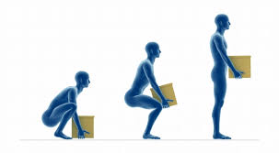

**Cumulative Trauma Disorders**

Musculoskeletal injuries caused by working are common. The majority of these injuries are not accident related broken bones or strained ligaments. They usually develop over a period of time as a result of repeated stress on a particular body part. The condition is often ignored until the symptoms become chronic and permanent injury occurs. Cumulative trauma disorders (CTDs) and repetitive motion injuries are terms used to refer to certain musculoskeletal injuries.

A key reason for the increase in CTDs is the increase in production due to automation. The assembly line, computerized office machines and electronic checkout stations in grocery stores are examples of workstations that require a high volume of output.

One simple, strain‐producing task may be repeated several thousand times a day. High production demands do not allow much time for rest and recovery

The aging work force relates to the incidence of CTDs because the ability to withstand shock, chronic strain, and stress decreases as an individual ages. Also, awareness of the causes and nature of CTDs has increased. Employers and employees can recognize tasks that cause or contribute to these disorders.

Recent studies have shown that a great deal of workers’ compensation costs is due to CTDs. CTDs are responsible for many cases of lost work time. Early detection of CTDs can be difficult because the disorders often develop slowly over months or years. Therefore, preventing CTDs is important. Prevention can, in part, be accomplished by tool and workstation redesign and better work methods.

**Work Area Design**

A workstation/area should be designed to accommodate the person who actually works on a given job. For example, workstations should not force workers into awkward body positions. Workstations should be easily adjustable and selected to fit specific tasks, so that they are comfortable for the workers using them. The workspace should be large enough to allow for the full range of required movements, especially where knives, saws, hooks, and similar tools are used.

Methods for reducing extreme and awkward postures include:

• Adjustable fixtures and rotating tables so that the position of the work can be easily manipulated.

• Workstations that can accommodate the heights and reach limitations of a wide range of workers.

• Work platforms that move up and down for certain operations.

Examples of methods to reduce the need to use excessive force include:

• Adjustable fixtures that allow operations and movements to be easily made.

• Properly located bins so that workers do not have to toss products and by‐products.

• Mechanical or powered devices that eliminate the need for extreme manual force.

• The suspension of heavy tools.

**Minimization of Manual Materials Handling**

Manual materials handling is another area in which injuries to employees can occur. At PSG we know all manual lifting cannot be eliminated. This type of work entails lifting, bending and twisting, which can cause great damage to the human body if done improperly. We do have a recommended safe lifting limit of #50. With anything above this weight, it should be our goal to move it with mechanical aids or other help such as a two man lift. Lifting puts stress on two main body systems. One is the musculoskeletal system and the other is the cardiovascular system. Since the problem associated with the cardiovascular system deals with oxygen consumption or increased heart rate, the focus of most information regarding lifting has been the musculoskeletal system. Most studies use criteria such as “stress in relation to capability over a given amount of time” as an index of the associated strain.

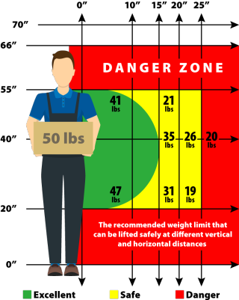

**Mechanical Aids**

There are many types of mechanical aids available to assist employees during manual materials handling. Hooks, bars, rollers, jacks, platforms, palette jacks, furniture carts and hand trucks are examples of simple job aids. In most cases, the Supervisor or Safety Director can find off‐the‐shelf aids readily available to fit the lifting task and to minimize the amount of manual lifting.

Other available equipment which will minimize, if not eliminate, manual materials handling includes the standard industrial equipment classes of conveyors, hoists and cranes, industrial vehicles (such as tow motor or forklift trucks). Today, with so much equipment available to use, manual materials handling can be reduced, if not eliminated, for most tasks.

**Office Ergonomics**

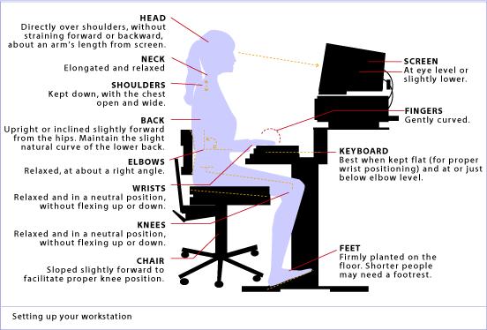

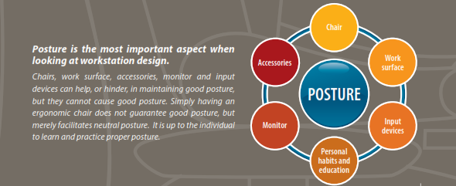

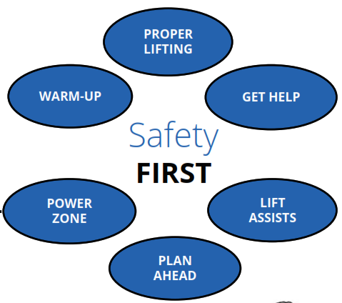

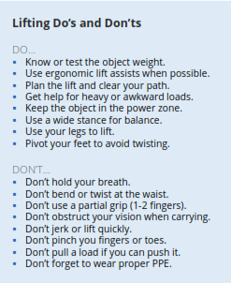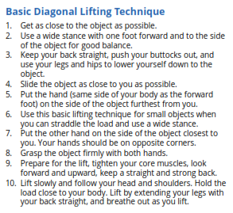

**Remember, a few minutes of warming up, stretching and planning can save a lifetime of pain!**

