**FIRE PROTECTION**

Piedmont Service Group (PSG) aims to prevent fires by the use of proper working procedures and good housekeeping and, in the event of a fire, to prevent injuries, loss of life, or damage to property by providing employees with the equipment and training necessary to extinguish incipient fires.

**Storage and Use of Flammable Liquids**

Flammable and combustible liquids require careful handling at all times. The proper storage of flammable liquids within a work area is very important in order to protect personnel from fire and other safety and health hazards.

*Flammable*: Capable of being easily ignited, burning intensely, or having a rapid rate of flame spread.

*Flammable Liquids*: Any liquid having a flash point below 140 degrees Fahrenheit and having a vapor pressure not exceeding 40 pounds per square inch (absolute) at 100 degrees.

*Combustible Liquid*: Any liquid having a flash point at or above 140 degrees Fahrenheit (60 degrees Celsius) and below 200 degrees Fahrenheit (93 degrees Celsius).

• Storage of flammable liquids shall be in NFPA approved flammable storage lockers or in approved structures at least 50 feet from any other structure. Do not store other combustible materials near flammable storage areas or lockers.

• Tanks must be grounded and bonded when dispensing flammable liquids from one tank to another.

• Portable containers of gasoline or diesel are not to exceed 5 gallons.

• Appropriate fire extinguishers are to be mounted within 75 feet of outside areas containing flammable liquids and within 10 feet of any inside storage area for such materials.

• Storage rooms for flammable and combustible liquids must have explosion-proof light fixtures.

•Bulk storage of gasoline or diesel are kept in above ground tanks. Tank areas shall be double walled or diked to contain accidental spills and shall be labeled in accordance with NFPA guidelines.

• No flames, hot work or smoking will be permitted in flammable or combustible liquid storage areas.

• Flammable liquid transfer areas are to be separated from other operations by 25 feet or by construction having a 1-hour fire rating.

• Maintenance and operating practices of all flammable liquid equipment shall be in accordance with established procedures, which will tend to control leakage and prevent the accidental escape of flammable or combustible liquids. Spills shall be cleaned up promptly.

• Inside areas in which Class I liquids are stored or handled shall be heated only by means not constituting a source of ignition, such as steam, hot water or forced central systems located away from the area.

**Storage Cabinets**

Not more than 120 gallons of Class I, Class II and Class IIIA liquids may be stored in a storage cabinet. Of this total, not more than 60 gallons may be Class I and II liquids. Not more than three such cabinets (120 gallons each) may be located in a single area.

**Storage Inside Buildings**

Where approved storage cabinets or rooms are not provided, inside storage will comply with the following basic conditions:

• The storage of any flammable or combustible liquid shall not physically obstruct a means of egress from the building or area.

• Containers of flammable or combustible liquids will remain tightly sealed except when transferred, poured or applied. Remove only that portion of liquid in the storage container required to accomplish a particular job.

• If a flammable and combustible liquid storage building is used, it will be a one-story building devoted principally to the handling and storing of flammable or combustible liquids. The building will have 2 hour fire-rated exterior walls and will be provided with ventilation to prevent the accumulation of vapors.

**Fire Extinguishers**

A portable fire extinguisher is a "first response" device and is very effective when used while the fire is small or in the incipient stage. The use of fire extinguisher that matches the class of fire, by a person who is well trained, can save both lives and property. The successful performance of a fire extinguisher in a fire situation largely depends on its proper selection, inspection, maintenance and distribution.

Fires are classified into four general categories depending on the type of material or fuel involved. The type of fire determines the type of extinguisher that should be used to extinguish it.

**•Class A**fires involve materials such as wood, paper and cloth which produce glowing embers.

**•Class B** fires involve flammable gases, liquids, and greases, including gasoline and most hydrocarbon liquids.

**•Class C** fires involve fires in live electrical equipment or in materials near electrically powered equipment.

**•Class D** fires involve combustible metals, such as magnesium, zirconium, potassium and sodium.

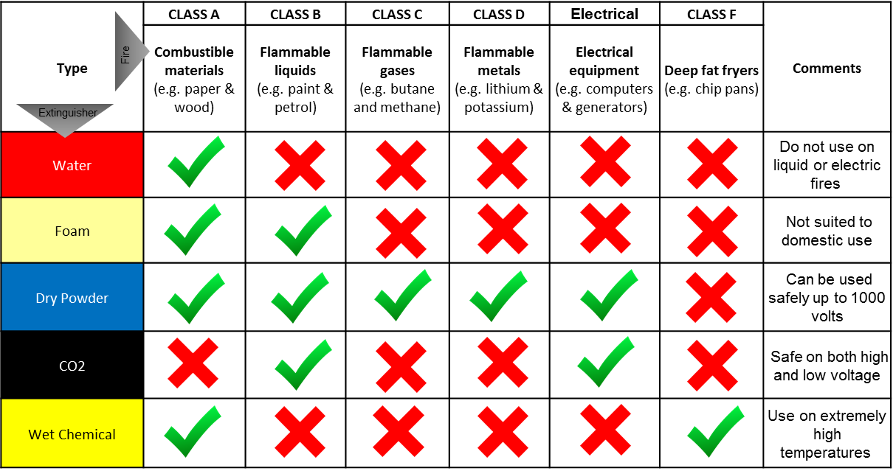

Extinguishers will be selected according to the potential fire hazard, the construction and occupancy of facilities, hazard to be protected and other factors pertinent to the situation.

Extinguishers will be conspicuously located and readily accessible for immediate use in the event of fire. They will be located along normal paths of travel and egress. Extinguishers will be clearly visible. In locations where visual obstruction cannot be completely avoided, directional arrows will be provided to indicate the location of extinguishers.

Portable extinguishers will be maintained in a fully charged and operable condition. They will be kept in their designated locations at all times when not being used. When extinguishers are removed for maintenance or testing, a fully charged and operable replacement unit will be provided. Extinguishers will be visually inspected monthly and an annually maintenance check performed.

Extinguishers will be installed on hangers, brackets, in cabinets, or on shelves. Extinguishers must be distributed in such a way that the amount of time needed to travel to their location and back to the fire does not allow the fire to get out of control. A fire extinguisher rated not less than 2A, shall be provided for each 3,000 square feet of the protected building area and travel distance from any point of the protected area to the nearest fire extinguisher shall not exceed 100 feet.

**Training**

Each employee working with flammable or combustible material or liquids will be trained in their proper use and storage and in the use of a fire extinguisher upon hiring or initial assignment and annually thereafter.

