**FORKLIFT SAFETY- POWERED INDUSTRIAL TRUCKS**

Material handling is a significant safety concern for Piedmont Service Group (PSG). During the movement of products and materials, there are numerous opportunities for personal injury and property damage if proper procedures and caution are not used. It is the policy of PSG that forklift operators be qualified operators. They will be trained in the safe operation, inspection, and maintenance of forklifts that they will be using. Being trained on one type of forklift does not authorize you operate them all. It is the responsibility of all operators to abide by all the regulations in 1910.178, site specific or situation requirements.

**Training**

No employees will be allowed to operate a forklift without being trained and authorized. Training is required every 3 years, if you are involved in an accident, you are observed operating the forklift in an unsafe manner or the situation requires it. You will be trained on the type of forklift you will be operating. This training will include at minimum:

#### • Operating instructions, warnings and precautions for the types of forklift you will be authorized to operate.

#### • Differences between the forklift and the automobile.

• The stability triangle principles.

• Truck controls and instrumentation: where they are located, what they do and how they work.

• Engine or motor operation.

• Steering and maneuvering.

• Visibility (including restrictions due to loading).

• Fork and attachment adaptation, operation and use limitations.

• Vehicle capacity, how to read load charts and vehicle stability.

• Any vehicle inspection and maintenance that the operator will be required to perform.

• Refueling and/or charging and recharging of batteries.

• Operating limitations.

• Considerations for surface conditions, travel area, load composition, other traffic and pedestrians.

• Inspection requirements.

• Hands on demonstration-evaluation.

**Inspection**

All forklifts will be inspected before each work period. This inspection will be documented. This inspection will include:

• Operator's training is current

• Emergency controls function properly

• The load chart/placard is attached

• All controls are labeled and function properly

• Seatbelt is functional

• Ropes/overhead guard is in place and functional

• Stabilizers/outriggers function properly

• All warning lights/alarms are in working order

• All manufacturer's decals are in place and legible

• All fluids are at their proper levels

• Fire extinguisher

• No structural defects

• Tires in good condition with the correct pressure if applicable

• Operator’s manual with the forklift

**Lift Types**

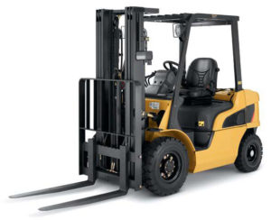 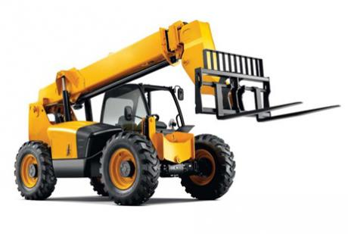

**Powered Industrial Truck All Terrain Forklift**

**Safe Operating Procedures**

• Seat belts will be worn at all times by the operator.

• The operator will perform daily pre- and post-trip inspections. Inspections can be documented

by using the *Fork Lift Inspection Form in the Appendix.*

• Any safety defects (such as hydraulic fluid leaks; defective brakes, steering, lights, or horn; and

or missing fire extinguisher, lights, seat belt, or back-up alarm) will be reported for immediate

repair or have the forklift taken "Out of Service".

• Loads will be tilted back and carried no more than 6 inches from the ground. Loads that restrict

the operator's vision will be transported backwards.

• Operator will sound horn and use extreme caution when meeting pedestrians, making turns and

cornering.

• Passengers may not ride on any portion of a forklift. Horseplay in not permitted.

• Normally forklifts shall not be used as a man lift. In the case that a forklift must

be used, an approved man lift platform (meeting the scaffold and manufacturer requirements) will

be used.

• Aisles will be maintained free from obstructions, marked and wide enough (six foot minimum)

for vehicle operation.

• Lift capacity will be marked on all forklifts. Operator will assure the load does not exceed rated

weight limits.

• Prior to driving onto trucks and trailers, their flooring shall be checked for breaks and other structural weaknesses. The flooring must be rated for the forklift and the load. The trailer wheels must be blocked.

• No workers or parts of their bodies are permitted under a load.

• No workers allowed in any area where they may be crushed between other objects.

• Grades shall be ascended or descended slowly. When ascending or descending grades in excess

of 10 percent, loaded forklifts shall be driven with the load upgrade. On all grades the load and

load engaging means shall be tilted back if applicable, and raised only as far as necessary to clear

the road surface.

• Only stable or safely arranged loads shall be handled. Caution shall be exercised when handling

off-center loads that cannot be centered.

• "Free Rigging" is not permitted. Only approved attachments can be used with rigging. No

hanging of rigging from the forks.

• When un-attended, forklifts will be turned off, forks lowered to the ground and parking brake

applied.

NOTE: When the operator is over 25 feet from or out of sight of the forklift, the vehicle is “unattended”.