**HAZARD COMMUNICATION PROGRAM**

**Purpose**

This program provides detailed safety guidelines and instructions for receipt, use and storage of hazardous chemicals at our facility and jobsites by employees and subcontractors.

Piedmont Service Group (PSG) is firmly committed to providing all of its employees with a safe and healthful work environment. It is a matter of company policy to provide our employees with information about hazardous chemicals on the worksite through our Hazard Communication Program, which includes a hazardous chemical inventory, container labeling, Safety Data Sheets (SDS) and employee information and training. This program is based on the Global Harmonized System (GHS) requirements. Every employee will have access to the SDS database which is stored in sdsbinderworks.com. This can be accessed with any electronic device. Login is provided in orientation and available to all at any time.

The Safety Director will have the ultimate responsibility to administer the Hazard Communication Program and to provide training to the employees.

**Employee Training and Responsibilities**

All new employees shall receive safety orientation training covering the elements of the HAZCOM and Right to Know and Understand Program.

This training will consist of:

• Location and availability of the written Hazard Communication Program in Piedmont Service Groups EHS Manual and the employees' Safety Handbook.

• Location and availability of the List of Hazardous Chemicals used in the workplace.

• Location of our SDS in **sdsbinderwork.com** and how to use a SDS. **USER: PSG PASS: Carolina**

• How to locate an SDS for a new chemical.

• Methods and observations used to detect the presence or release of a hazardous chemical in the workplace.

• The specific physical and health hazard of all chemicals in the workplace.

• Specific control measures for protection from physical or health hazards.

• Explanation of the chemical labeling system (labels, posters and forms of warning).

• Procedures to follow if exposed to hazardous chemicals.

In addition to the safety orientation training, employees will receive on the job training from their Supervisor/Foreman. This training will cover the proper use, inspection and storage of necessary personal protective equipment and chemical safety training for the specific chemicals they will be using or will be working around on that project.

**General Chemical Safety**

Some chemicals are explosive, corrosive, flammable or toxic. Other chemicals are relatively safe to use and

store but may become dangerous when they interact with other substances.

To avoid injury and/or property damage, workers who handle chemicals in any area must understand the hazardous properties of the chemicals. Before using a specific chemical, safe handling methods and health hazards must always be reviewed.

Supervisor/Foreman are responsible for ensuring that the equipment needed to work safely with

chemicals is accessible and maintained for all employees on all shifts.

The following general safety rules shall be observed when working with chemicals:

• Read and understand the Safety Data Sheets (SDS).

• Keep the work area clean and orderly.

• Use the necessary and required safety equipment/PPE.

• Carefully label every container with the identity of its contents and appropriate hazard

warnings.

• Store incompatible chemicals in separate areas.

• Substitute less toxic materials whenever possible.

• Limit the volume of volatile or flammable material to the minimum needed for short

operation periods.

• Provide means of containing the material if equipment or containers should break or

spill their contents.

**DO NOT p**our chemicals onto the ground.

**DO NOT** dispose of chemicals through the storm drain system.

**DO NOT** dispose of highly toxic, malodorous chemicals down sinks or sewer drains.

**Chemical Storage**

The separation of chemicals (solids or liquids) during storage is necessary to reduce the possibility of

unwanted chemical reactions caused by accidental mixing. Use either distance or barriers to isolate

different types of chemicals.

**Container Labels**

•Incoming chemicals are to be checked for proper labeling.

•All chemicals will be stored in their original or approved containers with the appropriate label, including chemical name, hazard pictograms(s), signal word, hazard statement and precautionary statements.

•Portable containers that contain a small amount of chemical need not be labeled if they are used

immediately that shift but must be under the strict control of the employee using the product.

•At no time shall unmarked containers of any size be left in the work area unattended.

•All warning labels must be maintained in a legible condition and not be defaced.

•All containers that are not labeled or on which the manufacturer’s label has been removed, will be relabeled in accordance with the GHS guidelines.

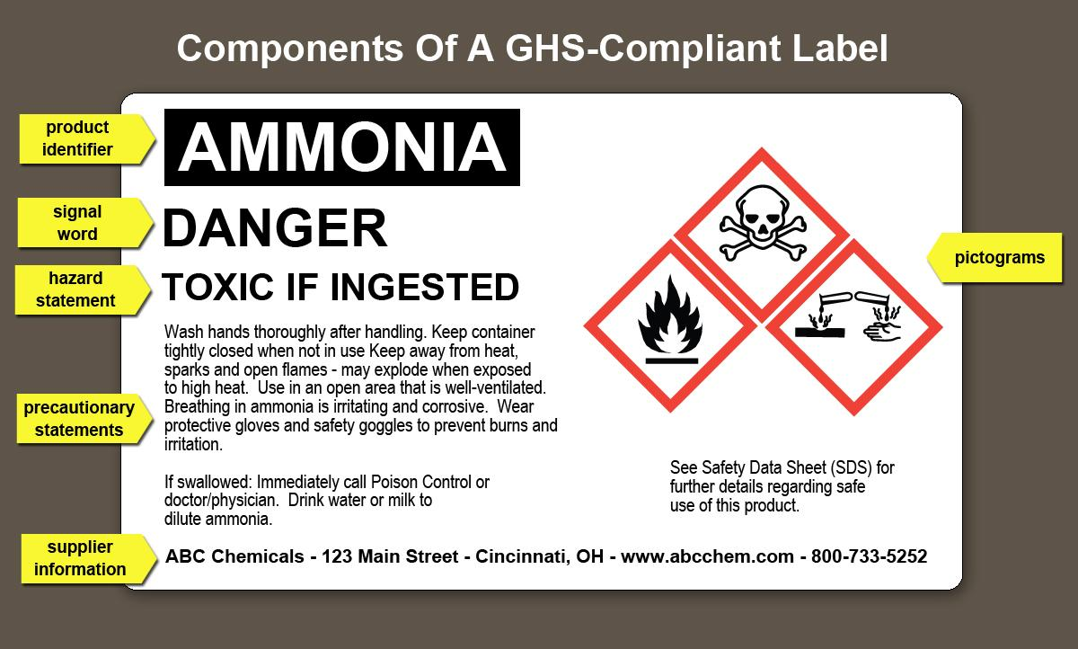

**Safety Data Sheets (SDS)**

The Safety Director is responsible for establishing and monitoring Piedmont Service Group's SDS Program. The Safety Director will make sure procedures are followed to obtain the necessary SDS and will review incoming SDS’s for new or significant health and safety information. He will see that any new information is passed on to the affected employee. The following procedure will be followed when the SDS is not received at the time of initial shipment. The foreman will then notify the Safety Director and he will contact the manufacturer of the chemical to obtain the SDS.

Rules to follow:

•The SDS contains 16-sections of valuable information about the characteristics, safety and health

hazards, protective measures and emergency response procedures for the hazardous chemical or

product. Any that do not follow this GHS format need to be updated.

•SDS for all hazardous chemicals in use will be kept in sdsbinderworks.com.

•All employees will be familiar with the operation of our electronic SDS database.

•All employees will have access to the database.

•If working in an area where access to the internet is limited, notify the Safety Director and paper copies will be made available.

•Discuss SDS's that are in use during Toolbox Safety Talks and Job Hazard Analysis discussions.

•Have employees demonstrate understanding of the pictograms

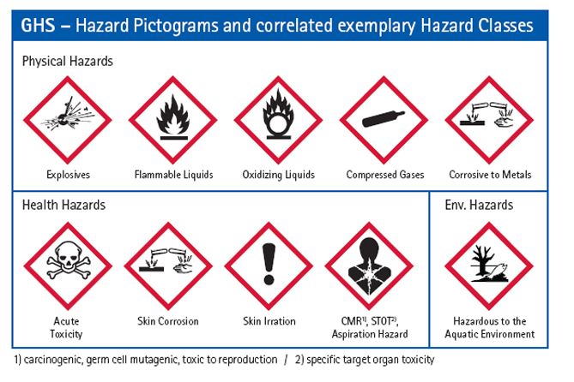

**Hazardous Non-routine tasks**: Periodically, employees are required to perform hazardous non-routine tasks. Example of non-routine task is confined space entry. Prior to starting such projects, each affected employee will be given information by the Supervisor/Foreman about the hazardous chemicals he or she may encounter during such activity. This information will include specific chemical hazards, safety measures the employee can use, steps the company is using to reduce the hazards, including ventilation, respirators, and emergency procedures.

**Informing Other Employers Working in Close Proximity:** The Supervisor/Foreman has the direct responsibility to provide other employers with information about hazardous chemicals their employees may be exposed to on a jobsite, including suggested precautions for the employees. On the other hand, the PSG jobsite Supervisor/Foreman is required to obtain information about hazardous chemicals used by other employers that our employees may be exposed to.

The following procedures will be used to inform other employers who have employees who may be exposed to hazardous chemicals in use by employees of PSG:

•If there is a hazard or the potential for one, all possible affected employers/employees will be notified.

•Safety Data Sheets will be provided to other employers if requested.

•Appropriate precautionary methods will be recommended to other employers to safeguard their employees.

•Other employers will be informed of the labeling system in use.

**PSG SDS LOCATION**

