**HEAT ILLNESS-COLD WEATHER SAFETY**

**Purpose/Scope**

Working in extreme temperatures (hot or cold) can overwhelm the body's internal temperature control system. When the body is unable to warm or cool itself, heat or cold related stress can result. Heat and cold stress can contribute to adverse health effects with a range in severity from discomfort to death. It is Piedmont Service Group's goal that no employee be exposed to "Heat Related Illnesses" in the workplace.

**Responsibilities**

Piedmont Service Group shall:

• Maintain, review and update the Heat Illness-Cold Weather Safety Program as needed.

• Provide monitoring (upon request) and assist employees with the development of procedures to minimize the adverse effects of heat and cold stress in the workplace.

• Provide training to employees required to be exposed to hot and cold weather

conditions. This will include the effects of hot and cold weather exposure and how to

protect themselves.

Supervisors shall:

• Review and comply with the provisions outlined in this program.

• Ensure all employees are properly trained before working in extreme temperature

conditions.

• Assess the day-to-day heat or cold stresses on employees.

• Assess employees work load and assigning work and rest schedules as needed.

• Ensure all employees have the appropriate personal protective equipment (PPE) prior

to working in extreme temperature conditions.

Employees shall:

• Review and comply with the provisions outlined in this program.

• Complete training before working in extreme temperature conditions.

• Wear the appropriate PPE.

• Report heat and cold stress concerns to their supervisor.

**Heat Related Illnesses; Signs, Treatment and Prevention**

While working in hot weather conditions, the human body may not be able to maintain a normal temperature just by sweating. If this happens, heat-related illnesses may occur. The most common health problems caused by hot work environments include:

**Heat Stroke** –

This is the most serious heat related effect. Heat stroke occurs when the body temperature increases above

104°F. Signs and symptoms of heat stroke are confusion, loss of consciousness and lack of perspiration.

This condition must be treated as a medical emergency and the employee must receive immediate medical

attention.

**Heat Exhaustion –**

Signs and symptoms of heat exhaustion include headache, nausea, dizziness, weakness, irritability,

confusion, thirst, heavy perspiration and a body temperature greater than 104°F. Employees experiencing

heat exhaustion should be moved to a cool area, given fluids to drink and given cold compresses for their

head, face and neck. Employees should also be taken to a clinic or emergency room to be monitored by

medical personnel.

**Heat Cramps –**

Signs and symptoms of heat cramps include muscle pains usually caused by the loss of body salts/fluids.

Employees should replace fluid loss by drinking water and/ or carbohydrate-electrolyte replacement

liquids (i.e. Gatorade) every 15 to 20 minutes.

**Heat Rash –**

Heat rash is caused by excessive perspiration and looks like a red cluster of pimples or small blisters. Heat

rash usually appears on the neck, upper chest, in the groin, under the breasts and in elbow creases.

Treatment for heat rash is to provide a cooler, less humid environment.

**Dehydration –**

Dehydration is a major factor in most heat disorders. Signs and symptoms of dehydration include

increasing thirst, dry mouth, weakness or light-headedness (particularly if worse upon standing), and a

darkening of the urine or a decrease in urination. Dehydration can be reversed or put back in balance by

drinking fluids that contain electrolytes (i.e. Gatorade) that are lost during work related activities. Avoid

caffeinated drinks.

While heat related illness are dangerous and potentially life threating, they can be prevented.

Prevention methods include:

*Acclimation* – Acclimation is a process by which the physical processes of an employee’s body adjusts to the environment over a period of time. Based on data obtained from OSHA, this process usually takes five to seven days. This process could take up to three weeks depending on the individual and their work environment. According to the American Industrial Hygiene Association, the process requires a consistent work level for at least two hours each day during the acclimation period in order for an employee to become acclimatized. Mere exposure to heat does not confer acclimatization, nor does acclimatization at one heat stress level confer resistance to heat stress at a higher temperature or more vigorous work load.

Employees who are not adequately acclimatized to the heat may experience temporary heat fatigue resulting in a decline in performance, coordination or alertness. They may also become irritable or depressed. This can be prevented through gradual adjustment to the hot environment. People in good physical condition tend to acclimatize better because their cardiovascular systems respond better.

*Engineering Controls -* For employees working indoors, the best way to prevent heat-related illness is to make the work environment cooler. Where and if possible, use air conditioning to cool the work area. Alternatively, increase the general ventilation as much as possible by opening windows or doors. When available, use cooling fans to aid in increasing ventilation.

*Safe Work Practices –* For employees working outdoors or working indoors without air conditioning or ventilation, take scheduled breaks in cool areas. Ensure there is plenty of cool water to drink and take water breaks as needed. Immediately report any problems to a supervisor. Supervisors should consider scheduling the hottest work for the coolest part of day, assigning extra employees to high demand tasks and using work-saving devices (i.e. power tools, hoists or lifting aids) to reduce the body’s work load. All employees should watch out for the safety of their coworkers.

*Heat Index –* The Heat Index is a single numeric value that uses both temperature and humidity to inform the public on how the weather outdoors “feels”. The higher the Heat Index, the hotter the weather feels. OSHA has used the Heat Index to assign protective measures for workers as the Heat Index increases. These protective measures may reduce the likelihood of heat related illnesses.

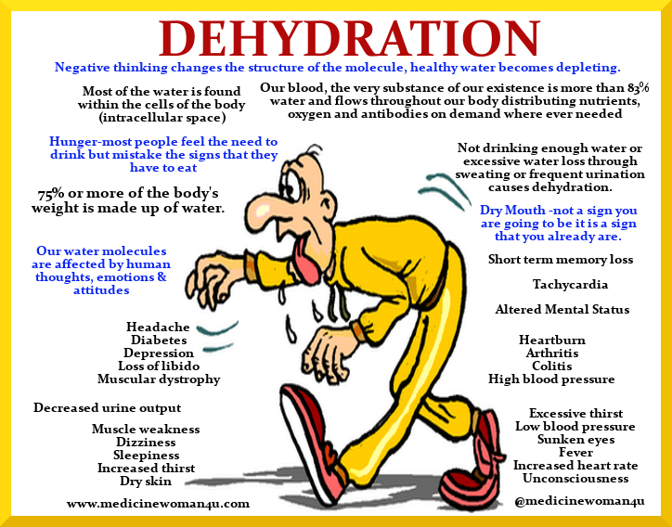

**Cold Related Illnesses**

During cold weather, an employee’s body will use energy to maintain a normal internal body temperature.

This will result in a shift of blood flow from employee’s extremities (hands, feet and legs) and outer skin to

the employee’s core (chest and abdomen). If this happens, cold-related illnesses and injuries may occur if

exposed to cold conditions for an extended period of time. It is Piedmont Service Group’s objective to

eliminate these illnesses/injuries.

**Signs, Treatment and Prevention**

The most common health problems caused by cold work environments include:

**Hypothermia** -

Hypothermia is a potentially serious health condition. Hypothermia occurs when body heat is lost faster

than it can be replaced. When the core body temperature drops to approximately 95°F, the onset of symptoms normally begins. The employee may begin to shiver, lose coordination, have slurred speech and fumble with items in the hand. The employee’s skin will likely be pale and cold. As the body temperature continues to fall these symptoms will worsen and shivering will stop. Once the body temperature falls to around 85°F severe hypothermia will develop and the person may become unconscious and at 78°F, vital organs may begin to fail.

Treatment depends on the severity of the hypothermia. For mild hypothermia move to a warm area and

stay active. Remove wet clothes and replace with dry clothes or blankets and cover the head. To promote

metabolism and assist in raising internal core temperature drink a warm (not hot) sugary drink. Avoid

drinks with caffeine. For more severe cases do all the above, plus contact emergency medical personnel

(call 911 for an ambulance), cover all extremities completely, place very warm objects, such as hot packs

for water bottles on the victim's head, neck, chest and groin. Arms and legs should be warmed last. In

cases of severe hypothermia, treat the employee very gently and do not apply external heat to re-warm.

Hospital treatment is required.

**Frostbite** –

Frostbite occurs when the skin actually freezes and loses water. In severe cases, amputation of the

frostbitten area may be required. While frostbite usually occurs when the temperatures are 30° F or lower,

wind chill factors can allow frostbite to occur in above freezing temperatures. Frostbite typically affects the

extremities, particularly the feet and hands. The affected body part will be cold, tingling, stinging or aching

followed by numbness. Skin color turns red, then purple, then white and is cold to the touch. There may

be blisters in severe cases. Do not rub the area to warm it. Wrap the area in a soft cloth, move the employee

to a warm area and contact medical personnel. Do not leave the employee alone. If help is delayed,

immerse in warm (maximum 105 °F) not hot, water. Do not pour water directly on affected part. If there

is a chance that the affected part will get cold again do not warm. Repeated heating and cooling of the skin

may cause severe tissue damage.

**Trench Foot** –

Trench Foot is caused by having feet exposed to damp, unsanitary and cold conditions including water at

temperatures above freezing for long periods of time. It is similar to frostbite, but considered less severe.

Symptoms usually consist of tingling, itching or burning sensation. Blisters may be present. For treatment,

soak feet in warm water, then wrap with dry cloth bandages. Drink a warm, sugary drink. Seek medical

attention if necessary.

**Dehydration** –

It is easy to become dehydrated during cold weather. Signs of dehydration include increasing thirst, dry

mouth, weakness or light-headedness (particularly if worse upon standing) and a darkening of the urine

or a decrease in urination. Dehydration can be reversed or put back in balance by drinking fluids that

contain electrolytes (i.e. Gatorade) that are lost during work related activities. Avoid caffeinated drinks.

Just as with heat related illness, cold related illnesses and injuries are dangerous and potentially life

threatening, however, they can be prevented. Prevention methods include:

*Acclimation –* Employees exposed to the cold should be physically fit, without any circulatory, metabolic or neurologic diseases that may place them at increased risk for hypothermia. A new employee should not be required to work in the cold full time during the first days of employment until they become adjusted to the working conditions and required protective clothing. New employees should be introduced to the work schedule slowly and be trained accordingly.

*Engineering Controls –* For employees working indoors, the best way to prevent cold-related illness is to make the work environment warmer. Where and if possible, use heaters to warm the work area. Alternatively, decrease the general ventilation as much as possible by closing windows or doors.

*Safe Work Practices –* For employees working outdoors or working indoors without heat, take scheduled breaks in warm areas. If available, use wind barricades to block the wind from the employees. Ensure there is plenty of water to drink and take water breaks as needed. Immediately report any problems to a supervisor. Supervisors should consider scheduling the most work for the warmest part of day, assigning extra employees to high demand tasks that will require longer periods in cold areas. All employees should watch out for the safety of their coworkers.

*Personal Protective Equipment (PPE) –* PPE is an important factor in preventing cold stress related illnesses and injuries. Employees should adhere to the following recommendations when dressing for work in a cold environment:

• Wear at least three layers of clothing; an inner layer of wool, silk or synthetic to wick

moisture away from the body; a middle layer of wool or synthetic to provide insulation

even when wet; an outer wind and rain protection layer that allows some ventilation to

prevent overheating.

• Wear a hat or hood; up to 40% of body heat can be lost when the head is left exposed.

• Wear insulated boots or other footwear.

• Do not wear tight clothing; loose clothing provides better ventilation.

• Keep a change of clothing available in case work clothes become wet.

*The Cold Stress Equation –* OSHA has incorporated information obtained from the American Conference of Governmental Industrial Hygienists (ACGIH) threshold limit values into the Cold Stress Equation. As the temperature decreases and/or the wind speed increases, the potential for cold stress related illnesses and injuries increases. See below.

