**INCIDENT INVESTIGATION POLICY**

Piedmont Service Group is committed to investigating all accidents, incidents and near misses. This is so we can determine the root causes and eliminate the unsafe actions and conditions that cause our employees to get injured. Our Safety Director will ensure that the incident investigation policy is followed. Those who are involved in investigating incidents will be trained how to conduct an investigation. Accidents, incidents and near miss/hits that result in personal injury, property damage, chemical spill or other emergency situations will be immediately reported to your supervisor at the time of the event and Emergency Medical Service, Fire Department or Hazmat Services will be immediately summoned. The Safety Director will then be called. Such events will be investigated and documented with the Incident Investigation Form. (This will be in your Incident Kit-AKA Grab and Go and the form is also located in the Appendix).

Employees are often reluctant to report an incident because of fear, peer pressure or concern that it may affect their job in some way. To ensure that incidents will be reported, employees must be encouraged to participate in the “fact-finding” process. The point emphasized must be that “hazardous conditions” and “unsafe practices” are an indication of a much bigger problem with a breakdown in the safety and health policy. The purpose of the incident investigation then becomes one that will uncover these system problems and provide solutions that will result in long term corrective action.

It is important to gather facts and interview witnesses as soon as possible after an incident to ensure the most accurate information is being recorded. The efficiency of the corrective measures is determined by the accuracy of the information gathered. The best place to conduct an interview is wherever the employee being interviewed feels most comfortable. The most important interviewing technique you can use to ensure accuracy is to “listen”.

***Root Causes***

Incidents occur when hazards escape detection during preventive measures, such as a job or process safety assessment, when hazards are not obvious and unsafe actions and conditions are allowed to exist. A thorough incident investigation may identify previously overlooked physical, environmental or process hazards, the need for new or more extensive safety training, or unsafe work practices.

The primary focus of any incident investigation should be the determination of the facts surrounding the incident and the lessons that can be learned to prevent future similar occurrences. The focus of the investigation should NEVER be to place blame. The process should be positive and thought of as an opportunity for improvement.

Most incidents in the workplace result from unsafe work behaviors. According to the latest research, they represent the direct cause of about 95% of all workplace incidents. Hazardous conditions represent the direct cause for only about 3% of workplace incidents. All these statistics imply that management system weaknesses account for fully 98% of all workplace incidents. Effective incident investigation identifies these root causes and recommends strategies to eliminate management system weaknesses. You will notice the word accident does not appear too often below. This is because true accidents only occur about 2% of the time.

***When Incident Investigations are Required-Who to Notify***

As a general rule, investigations should be conducted for:

**• All incidents with injuries (even the very minor ones).**

Notify your supervisor **immediately**

Notify the PSG Safety Director **immediately**

Notify the Owner/GC within 24 hours

OSHA will be notified if:

Fatality-notify within 8 hours

Hospitalization of one or more employees-notify within 24 hours

Amputation or loss of an eye-notify within 24 hours

**• Property and/or product damage situations.**

Notify your supervisor immediately

Notify the PSG Safety Director

Notify the Owner/GC within 24 hours

**• All “Near Misses” where there was potential for serious injury.**

Notify your supervisor immediately

Notify the PSG Safety Director

Near miss and incident reporting and investigation allow you to identify and control hazards before they cause a more serious incident. Accident/incident investigations are a tool for uncovering hazards that either were missed earlier or hazards where controls were defeated. It is important to remember that the investigation is only useful when its objective is to identify root causes. In other words, every contributing factor to the incident must be uncovered and recommendations made to prevent recurrence.

After an investigation has been completed, it will be shared with management and those involved. The goal of this is to identify and prevent this from reoccurring. After this, the report will be edited to remove names and places and then used as a "Lessons Learned" and sent to all so everyone can learn from this and avoid repeating.

**WHAT SHOULD WE FOCUS ON?**

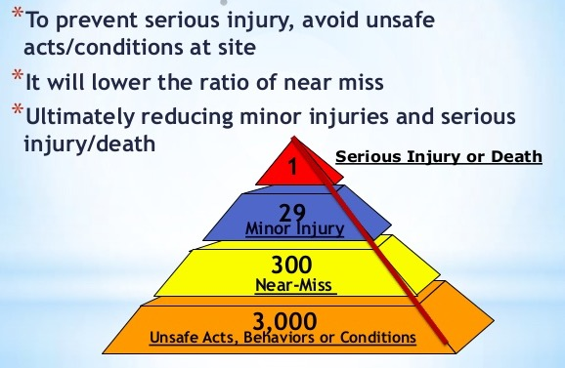

**DEFINITIONS EXEMPLIFIED**

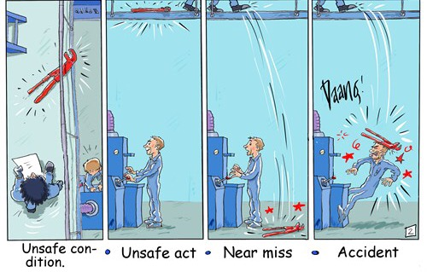

**HOW TO CONDUCT AN INCIDENT INVESTIGATION**

***Secure the Incident Scene***

For a serious incident, the first action the accident team will take is to make sure the scene is safe and then secure the incident scene so material evidence is not moved or removed. Material evidence has a tendency to walk off after an incident. If the incident is quite serious, OSHA may inspect and require that all material evidence be marked and remain at the scene of the incident.

***Gather Information***

The next step is to gather useful information about what directly and indirectly contributed to the incident. The following tools will be used to gather as much information as possible:

• Interview eye witnesses as soon as possible after the incident. Interview witnesses separately, never as a group. Put them at ease. Don't interrogate, give them time to explain all the details.

• Interview other interested persons such as supervisors, co-workers, etc.

• Review related records such as:

Training

Discipline

OSHA 300 Log (similar injuries)

• Document the scene by taking pictures.

• Take down other important information such as heights and distances. PPE that was being used, etc.

***Develop a Sequence of Events***

Use the information gathered to develop a detailed step by step description of the incident. Make sure the incident is documented in enough detail to enable an individual unfamiliar with the situation to envision the sequence of events. Do not just describe the incident itself; include a description of events that led up to the incident.

***Analyze the Incident***

The next step is to determine the root cause(s) of the incident. This is the most difficult step because first the events must be analyzed to discover surface cause(s) for the incident and then, by asking “why” a number of times, the related root causes are uncovered. Remember, surface causes are usually pretty obvious and not too difficult to determine. It may take a great deal more time to accurately determine the weaknesses in the management system, or root causes, that contributed to the conditions and practices associated with the incident.

***More on surface causes:***

The surface causes of accidents/incidents are those hazardous conditions and individual unsafe employee/manager behaviors that have directly caused or contributed in some way to the incident.

***Hazardous conditions may exist in any of the following categories:***

• Materials

• Machinery

• Equipment

• Tools

• Chemicals

• Environment

• Workstations

• Facilities

• Other workers

• Workload

**It is important to know that most hazardous conditions in the workplace are the result of**

**unsafe behaviors and actions that produced them. Individual unsafe behaviors may occur at any level of the organization.**

***Some example of unsafe employee/manager behaviors include:***

• Failure to follow safe work practices/company rules

• Using unsafe methods. "We have always done it this way"

• Taking shortcuts

• Horseplay

• Allowing unsafe behaviors

• Failing to supervise and correct

• Failing to train

• Failing to report injuries

• Failing to report hazards

• Scheduling too much work

• Ignoring worker stress

***More on root causes:***

The root causes for incidents are the underlying system weaknesses that have somehow contributed to the existence of hazardous conditions and unsafe behaviors that represent surfaces causes of incidents. Root causes always pre-exist surface causes. Poorly designed systems feed and nurture hazardous conditions and unsafe behaviors.

**Root Causes can be separated into 2 categories**

***1) System Design Weaknesses***

Missing or poorly designed policies and processes such as:

• Missing or inadequate safety policies

• Training programs not in place

• Poorly written plans

• Inadequate processes and procedures

**2)** ***System Implementation Weaknesses***

Failure to initiate or carry out safety policies, programs and procedures such as:

• Safety policies/rules not being enforced

• Safety training is not being conducted

• Adequate supervision is not being conducted

• Accident/Incident analysis is inconsistent

• Procedures not reviewed such as LOTO annually

***Developing Preventive Actions***

This is the most important piece of any investigation. All of the work done to this point culminates with recommendations to prevent similar incidents from happening in the future. Recommendations should relate directly to the surface and root causes of the incident. These recommendations will include preventive actions such as:

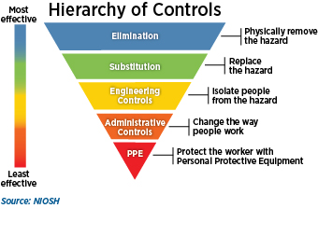

•**Elimination**-Remove the hazard. Ex-Lock Out Tag Out.

•**Substitution**-Replace the hazard. Ex-Hilti fasteners instead of drilling into concrete to create dust.

•**Engineering Controls**-Isolate the hazard. Ex-local exhaust ventilation for fumes.

**•Administrative Controls**-Minimize the hazard by work methods. Ex- worker rotation, ergonomics.

• **Personal protective equipment**-Ex-safety glasses and gloves.

It is crucial that, after making recommendations to eliminate or reduce the surface causes, that the same procedure is used to recommend actions to correct the root causes. If root causes are not corrected, it is only a matter of time before a similar incident occurs.

***In Summary***

A successful incident investigation determines not only what happened, but also finds how and why the incident occurred. Investigations are crucial as an effort to prevent a similar or perhaps more disastrous sequence of events. Research has shown that a typical incident is the result of many related and unrelated factors that somehow all come together at the same time. It is estimated that there are usually more than ten factors that contribute to a serious incident. Although, this combination of factors normally makes an investigation very time consuming and resource intensive, the good news is that the incident can normally be prevented by removing only a few of the contributing factors.