**SCISSOR LIFT AND AERIAL LIFT SAFETY**

The key to the safe operation of both Scissor and Aerial Lifts is proper training of personnel. Accidents often occur when employees do not fully understand the operations and capabilities of the lift they are operating. At Piedmont Service Group (PSG), we will ensure our users are trained to understand the hazards associated with the operation of Scissor and Aerial Lifts. The regulations referenced will be from 1926.452 Mobile Scaffolds and from 1926.453 Aerial Lifts. Some of what we require at PSG may be more than what is required in the standards.

**Training**

All employees using a Scissor or Aerial Lift will be trained and have demonstrated the ability to operate the style lift they will be using. Training will be for MEWP’s TYPE 3 Groups A & B in accordance with ANSI A92.22-24. For both Scissor and Aerial Lifts, fall restraint will be used. This will be a full body harness with a Self-Retracting Device (SRD). The SRD will be approved for this application by the manufacturer. The reason a SRD is used inside of a lift is because the manufacturer states that fall restraint will be used to keep the worker inside the platform and thus not expose the worker to any fall hazard requiring a fall arrest.

**Inspections**

The Scissor/Aerial Lift will be inspected at the time of delivery. Do not accept delivery of this machine if it needs repair. The inspection will be documented before each work period and include at minimum:

• Type and model of lift

• Date and operator's signature

• All emergency controls are in proper working condition

• All functional controls are in proper working condition

• The stabilizers/outriggers function properly

• All required decals are in place

• The operation manual is present

• It has a fire extinguisher

• All alarms function

• All guardrails, gates, mechanical and structural components function properly

• The source of power to the lift is in proper working order

• No other lift specific defects are found

• If damage is found the lift will be tagged and removed from service

• Type of rescue to be performed. Self, Assisted or EMS.

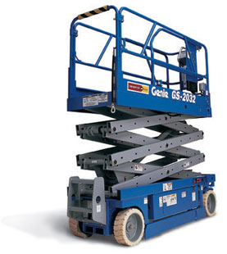  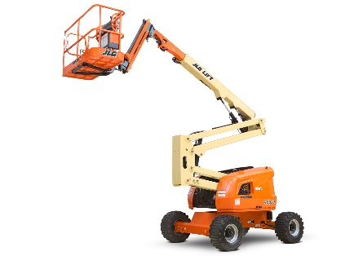

**Scissor Lift Type 3 Group A Aerial Lift Type 3 Group B**

**Safe Operating Procedures**

1. Lifts shall be used only by trained personnel and the lift must be inspected before use.
2. Fall restraint will be used in the lift. Even "riders' in the lift need fall restraint.
3. Lifts must not be loaded in excess of the designed working load.

1. Employees shall not sit, stand or climb on the guardrails of an elevating work platform or use planks, ladders or other devices to gain greater working height. If a worker needs to exit the lift for any reason while it is raised, see the procedure below.
2. Employees shall not work on lifts when exposed to high winds, storms or when they are covered with ice or snow.
3. When entering and exiting the lift, the worker will face the lift and maintain 3 points of contact.
4. Where moving vehicles are present, the work area shall be marked with warnings such as flags, roped off areas or other effective means of traffic control.
5. When there is the possibility of falling objects, barricade the area below.
6. When moving the lift, never stand in the extended area. Use a spotter if there are obstacles or other workers.
7. Look for unstable objects such as barrels, boxes, loose brick and tools. Debris shall not be allowed to accumulate on the work level.
8. Never elevate the platform unless the machine is on firm level surface.
9. Always survey the work area for surface hazards such as holes, drop offs, bumps and debris.
10. Never operate the machine if all guardrails are not properly in place.
11. Secure the chain across the entrance after mounting the platform.
12. Never attach overhanging loads or increase the platform size.
13. Always look up, down and around for overhead obstructions and electrical conductors.
14. Distribute all loads evenly, and make sure the maximum platform load is not exceeded.
15. Do not perform service on the machine while the platform is elevated without blocking.
16. Never recharge batteries near sparks or open flame.
17. After the final use of the day, secure the work platform by turning key switch off and removing the key.
18. Attachments must be approved by the manufacturer. No field modifications are acceptable.
19. Never operate the lift closer than 10' from energized high voltage lines.

|  |  |
| --- | --- |
| 600 - 50,000 volts | 10 Feet |
| 51,000 – 200, 000 | 15 Feet |
| 201,000 – 350,000 | 20 Feet |
| 351,000 – 500,000 | 25 Feet |
| 501,000 – 650,000 | 30 Feet |
| 651,000 – 800,000 | 35 Feet |
| 801,000 – 950,000 | 40 Feet |
| 951,000 – 1,100,000 | 45 Feet |

**Out of Platform Work**

At times it may be necessary to access an area by climbing out of a lift. In order to do this safely and be compliant, the following steps need to be followed:

1) A competent person investigates the tasks and determines the best and safest way to perform the task.

2) This task will be documented on the Job Hazard Analysis. (JHA)

3) If this task requires the workers feet to leave the platform of the lift and perform a task, a documented fall protection plan will be written. This can be completed on the JHA.

4) 100% fall protection is required for this. A double SRD set up is required for this transition.

5) An appropriate outside the platform anchor point needs to be used. Overhead is the best.

6) The worker stays connected to the lift as he climbs out of the lift.

7) The worker then installs his second anchor point and connects to it.

8) The anchor point inside the lift is disconnected.

9) The worker can now perform the task.

10) Once the task is complete, the worker climbs back in the lift and connects to it.

11) The worker then climbs out of the lift and disconnects his secondary anchor point and then climbs back into the lift.

*Points to remember:*

• If it's not documented, it is not compliant.

• At no time will you not be connected.

• While working in the lift, you are connected in the lift.

• If your feet are not on the platform, you are connected outside the lift.

• This option is the last resort.