**STAIRWAY AND LADDER SAFETY**

Ladders present unique opportunities for unsafe acts and unsafe conditions. It is Piedmont Service Group's (PSG) policy that all employees who use ladders must be trained in proper selection, inspection, use and storage. A competent person shall visually inspect ladders for defects before each use and after any occurrence that could affect their performance. Ladders found to be unsafe or defective shall be removed from service and tagged “Do Not Use”. All portable ladders must meet and be maintained per OSHA/ANSI standards. As a general rule, only Type 1A and Type 1AA are to be used. A different capacity may be used if it can be shown that the rating is sufficient for all workers and applications.



**Training**

All employees using or constructing ladders shall be trained to recognize hazards related to ladders and to

use proper procedures to minimize these hazards.  Employees shall be trained to demonstrate competency

in the following areas:

•The nature of fall hazards in the work areas.

•The proper construction, use, placement and care in handling of all ladders.

•The maximum intended load carrying capacities of ladders used.

•The type of ladder required for the task.

**Types of Ladders**

There are generally two types of portable ladders, Stepladders (A Frame Ladders) and Straight (Extension

Ladders). Each type of ladder has its own specific hazards and precautions.

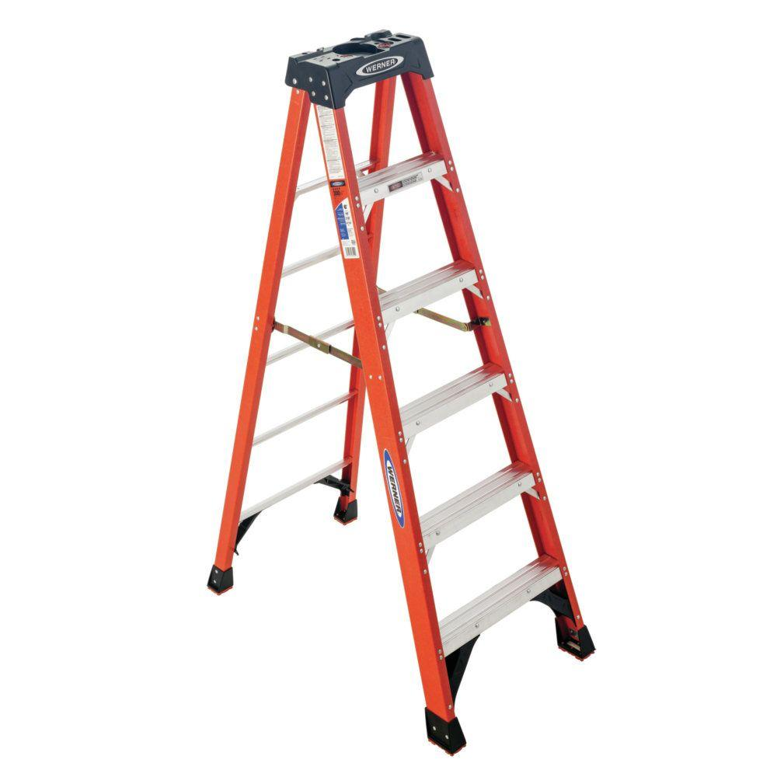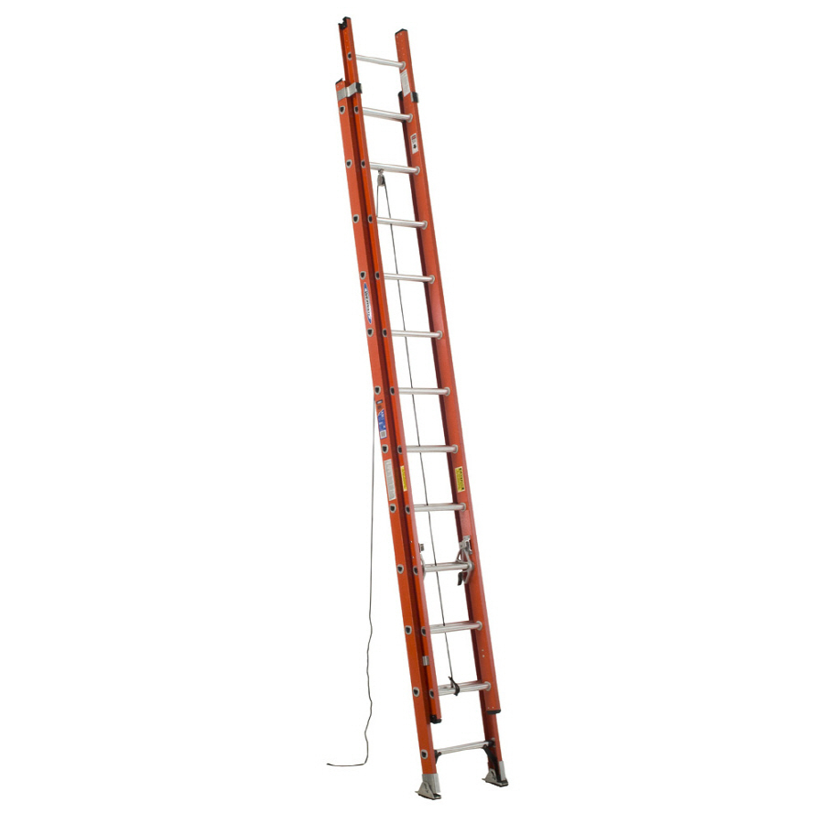

**Type 1A Stepladder Type 1A Extension Ladder**

**General Safety Guidelines**

•Ladders shall only be used for the purpose for which they were designed.

•Ladders shall be inspected before use. Defective ladders must be removed from service.

•Ladders shall be secured in position to prevent slipping.

•Always be sure to place the ladder on solid ground or footing.

•Ladder rungs and steps shall be parallel, level and uniformly spaced while in use.

•Ladders may not be used in horizontal positions for use as platforms.

•Wooden stepladders shall not be used.

•Metal ladders shall never be used on or around exposed electrical elements.

•Ladders shall be kept free of oil, grease, dirt, etc.

•Move the ladder with your work and do not overextend beyond the rails of the ladder.

•When climbing or descending a ladder always face the ladder and hold onto each rail.

•Carry tools and materials in proper carrying devices in order to keep your hands free.

•Do not exceed load limits specified for the particular ladder in use.

•Keep your belt buckle within the side rails. Do not reach past the ladder.

**Stepladder Safety**

•The top two steps are not to be used for standing or sitting on.

•The spreaders shall be fully extended and locked into place before use.

•Never lean the stepladder against a wall for use. Unless designed for this.

**Extension Ladder Safety**

•The ladder must be placed on a 4/1 angle.

•The ladder must be secured from movement.

•The ladder must extend 3' past the landing area.

•When used against a surface, the top 3 rungs are not to be used.

**Fixed Ladders**

These requirements primarily apply to our workers involved with maintenance or service work. They also

apply to anyone using fixed ladders 24' or taller. These regulations are taken from 1910 Subpart D Walking

Working Surfaces. With the new standard in effect, all ladders 24' and over are required to have a fall arrest

system or a ladder safety system. All PSG employees are required to use the system in place. The tables

below show the compliance dates to allow all to make their facilities compliant.

| **Subpart D Section** | **Compliance Date** |
| --- | --- |
| §1910.30(a) and (b) – Deadline by which employers must train employees on fall and equipment hazards | May 17, 2017 |
| §1910.27(b)(1) – Certification of anchorages | November 20, 2017 |
| §1910.28(b)(9)(i)(A) – Deadline by which employers must equip existing fixed ladders with a cage, well, ladder safety system, or personal fall arrest system | November 19, 2018 |
| §1910.28(b)(9)(i)(B) – Deadline by which employers must begin equipping new fixed ladders with a ladder safety system or personal fall arrest system | November 19, 2018 |
| §1910.28(b)(9)(i)(D) – Deadline by which all fixed ladders must be equipped with a ladder safety system or personal fall arrest system | November 18, 2036 |

**Stairway Safety**

Slips, trips and falls continue to injure our workforce. We often take stairs for granted. We need to keep our focus when using them and keeping at least one hand free to use the handrail. The standards referenced are 1910 Subpart D. Other references will be noted. We need to keep the following requirements in mind:

•There must be a stairway or ladder at points of access where there is an elevation break of 19 inches or more. 1926.1051(a)

•Clean up any spills or materials on stairways.

•The handrail must be able to withstand a force of #200.

•Stairways with 4 or more risers, or higher than 30", must have at least one handrail.

•Job made steps cannot have a riser height that varies more than 1/4".

•Do not use metal pan stairs without fillers or in their finished condition.

•A platform must extend 22" past the swing of the door.

