**COVID-19 (CORONA VIRUS) EXPOSURE CONTROL PROGRAM**

The purpose of this policy is to limit occupational exposure of employees to the COVID-19 virus.

It is the policy of Piedmont Service Group (PSG) that all employees shall use universal precautions in an attempt to eliminate or minimize employee exposure to COVID-19. All PSG employees shall have immediate access to this control policy. The work we perform is in the low risk category, but there are still risks to be considered.

**Procedures for Reducing Exposure Risks**

* The best way to prevent illness is to avoid being exposed to this virus.
* Avoid close contact with people who are sick.
* Avoid touching your eyes, nose, and mouth.
* Stay home when you are sick. 72 hours since your last symptoms.
* Cover your cough or sneeze with a tissue, then throw the tissue in the trash.
* Clean and disinfect frequently touched objects and surfaces using a regular household cleaning spray or wipe.
* Wash your hands with soap and water for at least 20 seconds, especially after going to the bathroom; before eating; and after blowing your nose, coughing, or sneezing.
* When you cannot wash your hands, use sanitizer with at least 65% alcohol.
* Hand sanitizer is available for all in 4 oz bottles at each branch.
* Practice Social Distancing. Stay at least 6' away from others.
* Wear a mask when in public or when 6' away is not possible.
* Refrain from physical greetings. No handshakes.

**Signs and Symptoms**

The most detailed breakdown of symptoms of the disease comes from a recent World Health Organization [analysis](https://www.who.int/docs/default-source/coronaviruse/who-china-joint-mission-on-covid-19-final-report.pdf) of more than 55,000 confirmed cases in China. Here are the most common symptoms and the percentage of people who had them:

* [Fever](https://www.webmd.com/lung/what-is-a-fever): 88%
* Dry cough: 68%
* [Fatigue](https://www.webmd.com/sleep-disorders/ss/slideshow-fatigue-causes-and-remedies): 38%
* Coughing up sputum, or thick [phlegm](https://www.webmd.com/allergies/features/the-truth-about-mucus), from the lungs: 33%
* Shortness of breath: 19%
* Bone or joint pain: 15%
* [Sore throat](https://www.webmd.com/cold-and-flu/understanding-sore-throat-basics): 14%
* [Headache](https://www.webmd.com/migraines-headaches/migraines-headaches-basics): 14%
* [Chills](https://www.webmd.com/a-to-z-guides/why-do-i-have-chills): 11%
* [Nausea](https://www.webmd.com/digestive-disorders/digestive-diseases-nausea-vomiting) or vomiting: 5%
* Stuffy nose: 5%
* [Diarrhea](https://www.webmd.com/digestive-disorders/digestive-diseases-diarrhea): 4%
* [Coughing up blood](https://www.webmd.com/lung/coughing-up-blood): 1%
* Swollen eyes: 1%
* Loss of smell

COVID-19 is a lower respiratory tract infection, which means that most of the symptoms are felt in the chest and lungs. That’s different from colds that bring on an upper respiratory tract infection, where you get a [runny nose](https://www.webmd.com/allergies/postnasal-drip) and [sinus](https://www.webmd.com/allergies/video/sinus-function-breathing) [congestion](https://www.webmd.com/allergies/sinus-congestion). Those symptoms seem to be mostly absent for people with COVID-19, though they’re not unheard of.

If you start to show symptoms, [call your doctor's office](https://www.cdc.gov/coronavirus/2019-ncov/about/share-facts.html). Don’t go there before calling -- that might spread the infection around the doctor’s office. They may want to talk to you on the phone in a telemedicine visit.

**Service Technician Safety**

* If you are sick, stay home.
* Wear a mask when changing filters, working on ductwork, when closer than 6’ to a person or when in public. This includes inside of a vehicle.
* All technicians shall wear gloves (cut resistant gloves are acceptable). This is our policy.
* Wash your hands or use Hand Sanitizer after every job/break.
* Get in the habit of sanitizing your tools. Use the sanitizer given to you.
* Do not let others use your tools.
* Do not put used filters inside your vehicle unless they are in a bag and sealed.
* Use XOI to document your service call, do not pass your phone to anyone for a signature.

**New Construction/Project Safety**

* If you are sick, stay home.
* Practice Social Distancing. Stay 6' away from others. This means even your own crew.
* Wear a mask if closer than 6’ to a worker or when in public. This includes inside of a vehicle.
* All workers shall wear gloves (cut resistant gloves are acceptable). This is our policy.
* Wash your hands or use Hand Sanitizer after every job/break.
* Get in the habit of sanitizing your tools. Use the sanitizer given to you.
* Do not let others use your tools.
* If Social Distancing is an issue, contact your Supervisor for further instructions. There are a number of options that may be implemented such as crew staggering, shift adjustments, or other.

**Office worker Safety**

* If you are sick, stay home.
* Practice Social Distancing. Stay 6' away from others. This means even at lunch or break.
* If you cannot stay 6' away, use a mask.
* Wash your hands or use Hand Sanitizer after every task/break.
* No visitors allowed without an appointment-no walk ups.
* Some positions may at times work remotely. This direction will come from your manager.

**If Exposed to COVID-19**

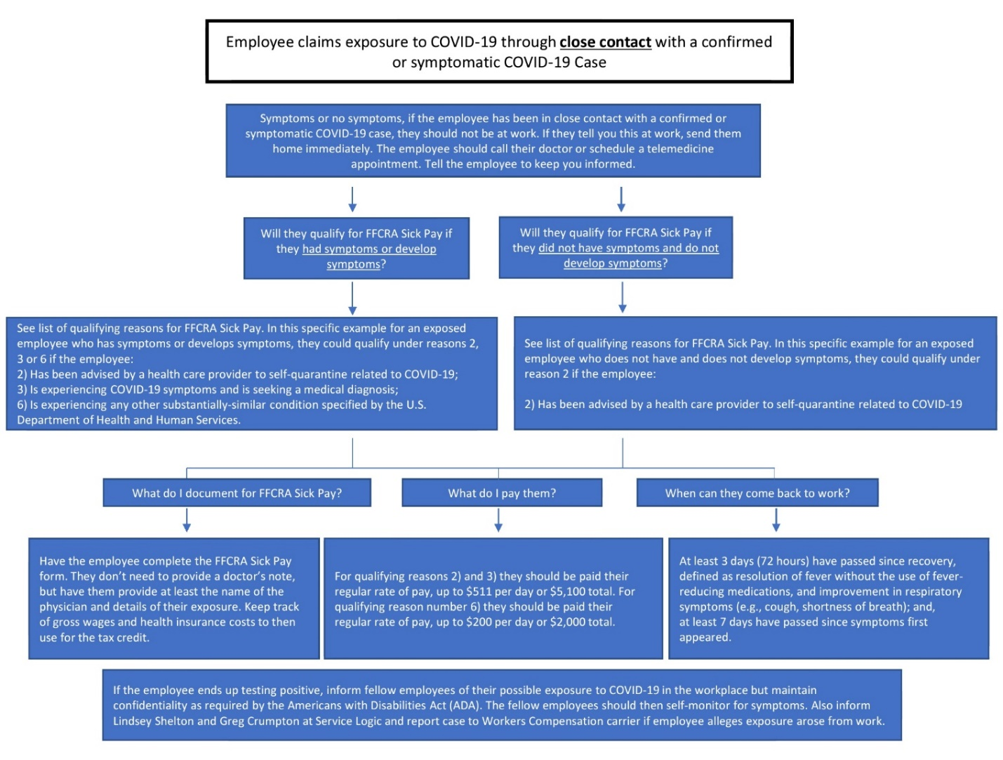

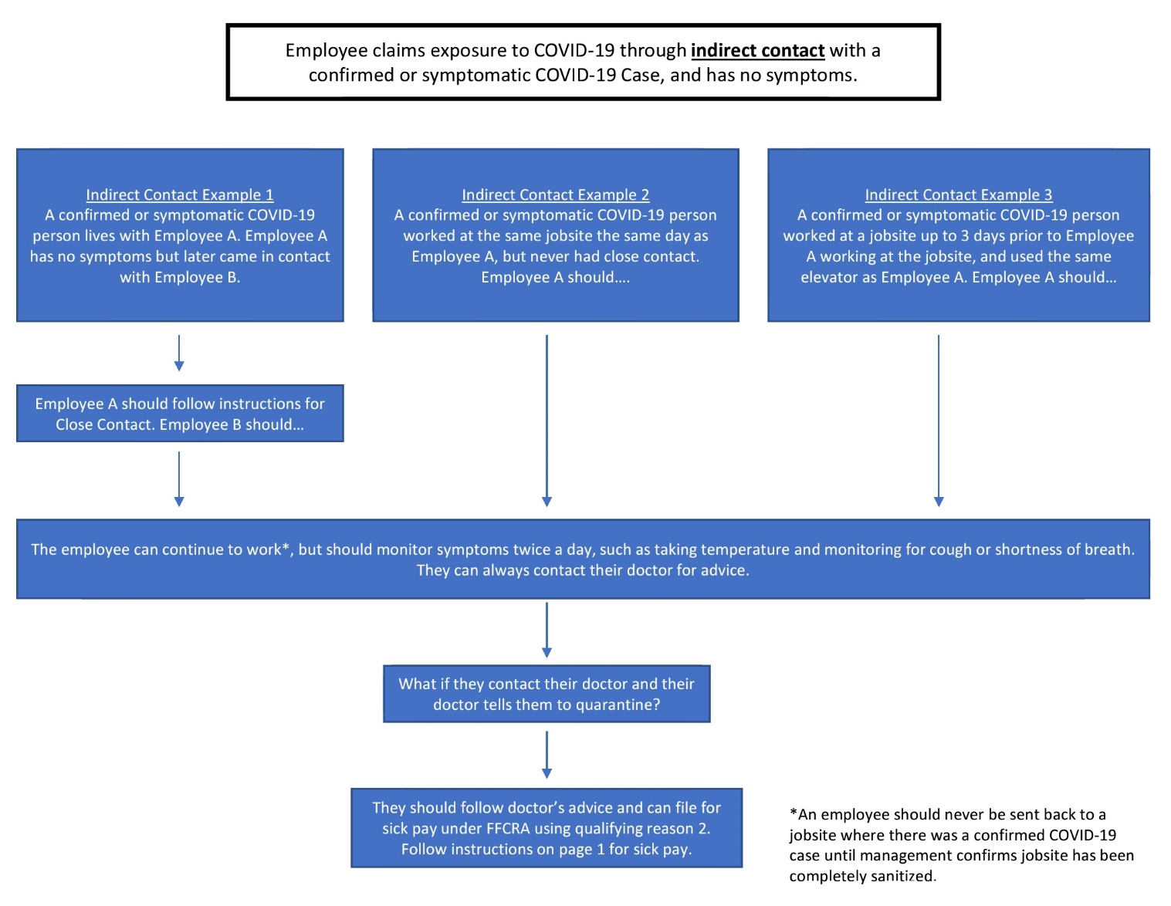



**Definitions**

**Close Contact:**

• Someone who was within 6 feet of an infected person for a cumulative total of 15 minutes or more over a 24-hour period* starting from 2 days before illness onset (or, for asymptomatic patients, 2 days prior to test specimen collection) until the time the patient is isolated.

**•** Caring for, living with, visiting, or sharing a health care waiting area or room with a COVID-19 case.

• Having direct contact with infectious secretions of a COVID-19 case (e.g., being coughed on).

**Indirect Contact:**

• Having a second, third or more degree of separation with a COVID-19 case.

• Being in the same building or area as a COVID-19 case, but never having Close Contact.

Please realize that the direction given here may change since this is an evolving pandemic. If you ever feel there is a danger, remember, see something-say something.

**Return to Work Requirements**

**I think or know I had COVID-19, and I had symptoms**

You can be around others after:

* 3 days with no fever **and**
* Symptomsimproved **and**
* 10 days since symptoms first appeared

**OR**

You will get tested to see if you still have COVID-19. A negative test result is required before being cleared for work or to be around others.

Note: Dead COVID 19 from a nasal swab may still generate a positive test result up to 6 weeks after the infection.

A face mask will be worn at all times when around people.

The worker also needs to be able to perform his normal job duties.

**I tested positive for COVID-19 but had no symptoms**

If you continue to have no symptoms, you can be with others after:

* 10 days have passed since test

**OR**

You will get tested to see if you still have COVID-19. A negative test result is required before being cleared for work or to be around others.

A face mask will be worn at all times when around people.

The worker also needs to be able to perform his normal job duties.

**Tracing Guidelines**

We know that a person with COVID-19 may be contagious 48 to 72 hours before starting to experience symptoms. Emerging research suggests that people may actually be most likely to spread the virus to others during the 48 hours before they start to experience symptoms.

Considering a minimum of 72 hours prior to the first symptoms, the following must be notified.

All the employees that had close contact with the infected person need to be notified. They need to be tested and quarantined.

All the facilities the employee visited need to be notified. Use The Service Logic provided form.

Those employees that had indirect contact need to be notified to monitor their symptoms but can still work.

**Acting quickly is key to minimizing the effects of this pandemic.**